English

14/09/2022

Kind regards

|  |  |
| --- | --- |
| **Formal** | **Informal** |
| It was a pleasure to meet you. Goodbye | Hey ! What are you up to? |
| Have a nice day, bye! | I’II have to go now, bye! |
| I am looking forward to meet you again | Good evening, what’s up? |
| How have you been? | Have a nice day, bye! |
| Very well thank you. How about you? | Fine, thanks and you? |
| Thank you for your time. | See you later  Good morning how are things?  Long time, no see (not English, don’t use )  Good afternoon. How do you do? |

Introducing yourself:

* Can I introduce myself? My name is …

Greeting somebody:

* How do you do (more casual)
* Pleased to meet you.
* How are you? (better)

Introducing a colleague:

* I’d like you to meet

Making small talk:

* Is this your first visit to …?
* How long have you been working for …?
* When did you join your company?
* What do you do for a living?

Talking about your job:

* I’m in charge of… (It department, sales etc)
* I’m responsible for …

Showing interest:

* Really?
* That sounds interesting

16/09/2022

* Daniel Goldman: Susan, I’d like you to meet Miles Henderson from Greentech Ltd.
* Susan Clarke: How do you do, Mr Henderson?
* Miles Henderson: Pleased to meet you. So what do you do here?
* Susan Clarke: I’m in charge of our IT department. And you?
* Miles Henderson: I’m responsible for sales and marketing
* Daniel Goldman: How long have you been working for your company?
* Miles Henderson: Oh, I’ve been with Greentech for almost five years now. How about you? When did you join your company?
* Daniel Goldman: I started working for Xcel Systems about 10 years ago.
* Daniel Goldman: Is this your first visit to Boston, Mr Henderson?
* Miles Henderson: No, actually, I’ve been here four times already.
* Daniel Goldman: Really? On holiday or business?
* Miles Henderson: Mostly business.

Or

* Daniel Goldman: Susan, I’d like you to meet Miles Henderson from Greentech Ltd.
* Susan Clarke: How do you do, Mr Henderson?
* Miles Henderson: Pleased to meet you. So what do you do here?
* Susan Clarke: I’m in charge of our IT department. And you?
* Miles Henderson: I’m responsible for sales and marketing
* Daniel Goldman: Is this your first visit to Boston, Mr Henderson?
* Miles Henderson: No, actually, I’ve been here four times already.
* Daniel Goldman: Really? On holiday or business?
* Miles Henderson: Mostly business.
* Daniel Goldman: How long have you been working for your company?
* Miles Henderson: Oh, I’ve been with Greentech for almost five years now. How about you? When did you join your company?
* Daniel Goldman: I started working for Xcel Systems about 10 years ago.

|  |  |
| --- | --- |
| Informal | formal |
| ask | Enquire |
| Ask for | Request |
| Book | To reserve/ make a reservation |
| Check | Verify (inspect) |
| Get | Receive/acquire/ obtain |
| Tell | Inform |
| Say no | Decline/refuse/reject |
| But | However/although/nevertheless/nonetheless |
| Think about | Consider/ take into account |
| Get in touch | Contact |

Create your own “small talk” scene in a business setting

Guidelines:

You can be meeting a new colleague, collaborator or client (Pairwork ). It could be at a conference, workshop, meeting, business party. You decide!

You can use sentences you have seen earlier.

Invent your own scene, write down your conversations and enact it in front of the class!

Elisee: Good Morning, Miss and Mr, please take a seat

Maeva: Good morning, I’d like you to meet my business partner Lucas.

Lucas: Glad to meet you, the weather is good today, isn’t it?

Elisee: Indeed, the weather seems to be good. Did you two have a good trip?

Maeva: We did, the flight was quite long, however the taxi ride here was fast.

Lucas: how about you, do you live far from here?

Elisee: Not really, I am only 15 minutes away

Lucas: how long have you been working for this company?

Elisee: I have been working for the past 7 years as a software engineer within the company

Maeva: Moreover, what are your specialities in this domain

Elisee: I am specialised in full stack web development, I have been senior software engineer for almost 2 years now.

Maeva: Lucas here is our main investor which is why I brought him herer today

Elisee: Mr Lucas, why are you interested in our company?

Lucas: Mostly the advertisement I saw from your company, however Maeva also guided me towards your company as she has previous experience and knowledge about your work.

Elisee: Alright great, shall we start talking business?

21/09/2022

Yarn: en fil

Weave: tricoter

Exercise 1: Write down the main theme(s)/ideas of the video (from diversity and inclusion)

You have to fit in order to be accepted by the colleagues, it’s hard to be accepted if you are yourself, he was rejected in the beginning because he didn’t look the same as others; he has to change how he behave, the way he looks with the suit etc.

But when another ball of yarn came into the company

Racism (that’s why they were in different color (the ball), pearl is a woman, that’s why she was pink, not looking the same, looking different, got over interest, laptop completely knitted, smaller than the over

Making jokes, loosing yourself in order to be accepted

It shows that you have to forget what she is and completely change and transform to fit in.

You can be discriminate if you are different, but you change

Be yourself, it takes one person to make a difference, start the change

Knitting: tricoter

Oral exam: work environment in the It industry, you need to be able to analyse the video, give your opinion, 10 minutes to prepare for the text, the picture and the video; presentation: 20 minutes to talk

2. Answer 3 of the following questions:

- What is diversity?

- What is inclusion? What does it mean to you?

- Are there more men or women in the IT field?

- Is it above or below the average for your industry?

- Do you feel that your unique attributes, traits, characteristics, skills, experience and background are valued?

Diversity (variety): including people of different social, ethnic backgrounds, different gender and sexual orientations,

Inclusion: to be include, to be accepted the way you are

In the IT field there are more men than woman

Correction:

Diversity: Diversity is recognising the differences of people within a community

Inclusion: is simply accepting people irrespective (peu importe) of their differences within a group.

True, there are more men in the It field than women, but compare to other fields there is a bigger proportion of women, it also depends on the department and the country, men have more high position than woman in general.

|  |  |  |
| --- | --- | --- |
| **ADJECTIVE** | **SYNONYM** | **ANTONYM** |
| **Diverse** | Varied | Homogenous, Uniform |
| **Tolerant** | Open-minded | Intolerant, Narrow-minded |
| **Typical** | Ordinary | Untypical, unusual |
| **Biased** | Prejudiced | Fair, equal |
| **Respectful** | Considerate | disrespectful |

23/09/2022

Ellipsis = points de suspension

Trait d’union = hyphen

Listening

Open, open a door and it open all the overs, open a mind and see what happens next

No great things , no beautiful invention was created in a vacuum

Il happens when we leave our confort zones and come together

Embrace faith, disabilities, cultures, ideologies, personalities, creating a tool or device nobody saw coming

The best way the world works is everybody in, nobody out

Differences not just celebrate but no essential

Equal pay for equal work

New generation of apple, more diverse than the one that came before

Open= who we believe as a company

Humanity isn’t singular, it’s plural

Power and truth: we don’t see things the same

* When does innovation happen in a company according to the video?
* What is meant by “humanity is plural”?
* What is the core value of the Apple company as mentioned here?
* Why is it important to be diverse in this company?

1. Innovation happen when we leave our comfort zones
2. Everyone is different, because each one will have a different culture, personality, age, gender, beliefs, faiths, etc.
3. Everybody in, nobody out, we need to include, integrate everyone.
4. It’s important to have a new vision of things, so we can learn from others

Correction

4- We need different perspectives in the company, that is why they employ from different cultures etc

Read the text below and complete it with the correct forms of the words provided

1. Ethnic : ethnicities
2. Orient: orientations
3. Correct: correctness
4. Simple: simply
5. Homogenity: homogeneous
6. Accept: acceptance
7. Personal: personally
8. Respect: respected

Ethnicities

Orientations

Correctness

Simply

Homogeneous

Acceptance

Personally

Respected

Ensuring: assuré

Abilities: compétences

Opportunity: opportunité

Problem solving: resolution de problèmes

The flip-side of the same coin: la face de la même pièce

Foster: mettre en place

Hold (has) the greatest sway: hold the greatest influence

Correction:

Ensuring: veillé, Assurant

Abilities: competences, abilités, capacités

Opportunity: occasion

The flip-side of the same coin: l’envers du décor, le revers d’une médaille

Foster: favoriser, mettre en valeur, promouvoir

Think group share : to build and share opinions

Let’s think of the pros and cons of promoting diversity and inclusion in the IT field… Present them to the class

|  |  |
| --- | --- |
| Pros(Benefits) | Cons (disadvantages) |
| Innovation and Creativity | If you are in an old fashion company, it can change the way you are treated, |
| Financial Results Improvement | language barriers, Financial Impact in the Short-Term |
| Competitive on a Global Scale | social tension, |

# Is Workplace Diversity Worth It? Here Are A Few Pros and Cons.

Right now the workforce in the United States includes more than 25 million people who are foreign-born. And, in less than 30 years some data suggest that the United States will become a truly pluralistic nation with no single segment of the population holding a majority. This is the face of what is to come, and if you expect to succeed and compete on this new playing field, you and your company need to have a good look at the pros and cons of workplace diversity.

## Pro: Financial Results Improvement

Many studies have shown that companies with higher degrees of diversity on their teams tend to show more profitability than others. Publicly traded companies were the focus of a [report](https://www.mckinsey.com/business-functions/organization/our-insights/why-diversity-matters) by consulting firm McKinsey & Company in 2015. Most notable was 35 percent more likelihood of financial success by those companies with the most epic and racial diversity in their management structure.

## Pro: Competitive on a Global Scale

Foreign owned companies employ a large percentage of the overall American workforce. In today’s global economy the Fortune 500 list of companies consistently features foreign owned companies near the top. To effectively compete on the global stage, companies must seek out diverse workforces who mirror the diverse population and points of view they serve. To effectively compete on the global stage, companies must seek out diverse workforces who mirror the diverse population in points of view they serve.

## Pro: Decision-Making Based on Facts

An often overlooked by-product of diverse organizations is that they tend to focus on facts in their decision making process.  examining and re-examining facts, in order to remain objective, these groups shy away from old ways of thinking. This results in better decision making for their company. Homogeneous groups have more difficulty identifying biases than their non-homogeneous counterparts, who are able to move past bias in the business decision process.

## Pros: Innovation and Creativity

An old saying goes something like repeating the same activity over and over will produce the same results. So, in business the same approaches to management sales products and the like will yield the same results, unless something is done to interrupt the pattern. Believe it or not, this is due to a lack of diversity. when a group of people approach challenges or problems from different perspectives however, more creative solutions will develop. Diversity supports market growth and fosters innovation.

## Advantage: Cross-Cultural Understanding

While “birds of a feather flock together“ may be all warm and fuzzy, as global diversity increases, cross cultural understanding helps create better working conditions and builds international understanding. Instead of sticking to the prejudice and misconceptions which have been prevalent here for, diverse workforces enhance the working environment and improve outward looking results for their organizations.

## Con: Transitioning Challenges

If the potential benefit of diversification is just making its way into view for your company, you will certainly encounter challenges when creating your new diverse work environment. Older ideas and entrenched habits will certainly present challenges while bringing conflict and increased tension among the team. Clashing cultures may create instances of misunderstanding of meanings. Something may be highly disrespectful to one culture when it is a joke in another. The most important element to launch your venture into workplace diversity is the buy-in of management and a sound educational approach for the rest of the company, in order to be successful.

## Con: Financial Impact in the Short-Term

You may already have experience in the area of accommodation in the workplace if you’ve been in business for some time. Similar to the way the Americans with Disabilities Act (ADA) brought a sea of change to many companies with some financial impact, diversity will also require some flexibility and initial cost outlay. Here’s one example; Muslim workers need a space for daily prayer. Transgender or non-binary employees need their own changing and/or restrooms. Simply, as your diversity increases, there may be unanticipated costs along the way.

Even though the transition to creating a more diverse workplace has its challenges, companies across the country and around the world are still making their moves to diversity. In the long run the effort and investment are proving to show their value, while the results provide both financial and moral rewards.

Opportunities with workplace diversity and inclusion in mind are on our [Job Search Engine](https://equalitymagazines.com/find-a-job-mobile/).

28/09/2022

Are you ready for a quiz on emailing?

Faithfully yours,

Sincerely yours,

Best Regards,

Kind Regards,

To whom it may concern is: an opening to a formal letter

3. Please find attached: formal and more polite

Find joint file: casual

Kindly see attached: used to

Please look at the following: informal

Dear manager

Dearest: love that person

What is the French word for “memo”?

Memo: une note

Thank you for your email: formal

Thanking you in anticipation, in advance

Thanks loads:

Apologies for the inconvenience caused

Sorry for the issue: informal

In

Cordialement: Kind regards, Best regards, Faitfuly yours

About this project: regarding this project

Enough details: Sufficient details

Settle the payments: pay the fees

I am writing to request for information

Write 1-2 sentence(s) to say each of the following in a formal email:

* Explaining the reason for writing (expliquer la raison de la rédaction de ce courriel)
* Sharing bad news with the staff (partager les mauvaises nouvelles avec le personnel)
* Giving deadlines (Donner des délais)
* Giving instructions for a particular task (Donner des consignes pour une tâche particulière)
* Suggesting appointments/meetings (Proposer des rendez-vous/réunions)
* Talking about attachments and links (Évoquez les pieces jointes et les liens

1. I would like to talk to you about
2. “I'm afraid I've got some bad news…”

“We regret to inform you that..”

I'm really sorry to have to say this but..”

Unfortunately, there are some problems with…”

* Due to…”
* Because of…”
* I can see that you're really upset and angry…”
* I can see why you might think that…”

by [date and time] because [reason]” ...

“When you have a chance [in the next day, before tomorrow, this week]” ...

“I apologize for the urgency, but could you please [do X, send me Y, complete Z] at your soonest possible convenience?” ...

“EOD”

Firstly I am writing to inform/to request/ to provide/to complain

Following our discussion or our previous discussion I would like to suggest/ to propose

I would like to apologize for

I regret to inform you that

It is with much regret that I have to inform you

The results will be needed for Monday morning

I will appreciate if this, if the project is submitted by

Giving instructions for particular tasks:

Please follow or kindly follow the instructions below

Please note that the following actions/requirements would be required

I would like to schedule a meeting on

I would like to arrange for a meeting on

Please do not hesitate to contact me by/on

Please find attached

Please refer

Kindly refer to the attached/enclosed documents

Jade 35 + 10 + 30

Maeva 45 + 10 + 30

Lucas 25

ELisee 25 +10

Nikil 10

Andi +10

30/09/2022

Postman: email

Letter:

Mailbox

Electronics

Notification, alarm, reminder

Notify

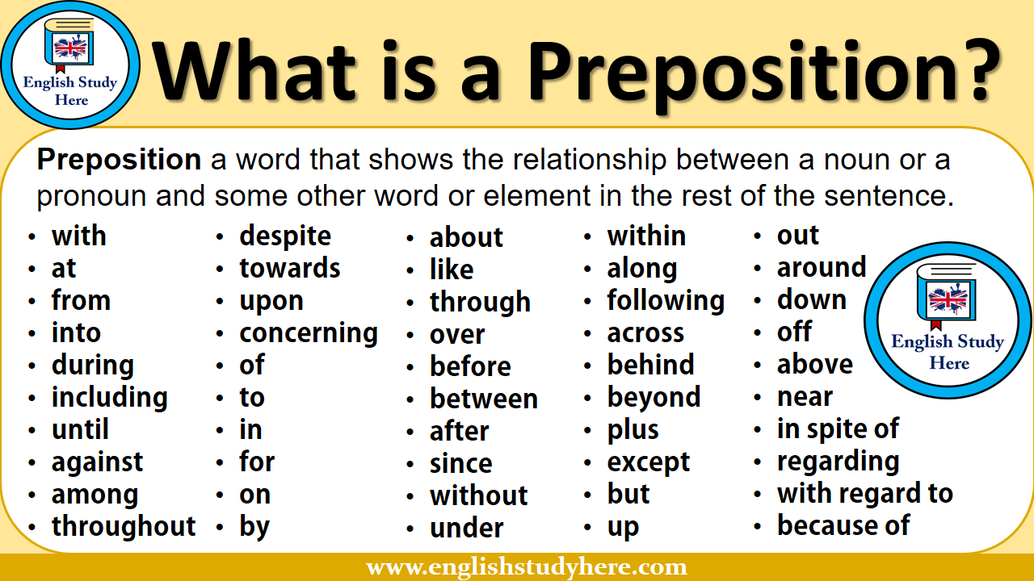

Reviewing: Prepositions for emailing

1. The internship typically lasts *up to/ for*  two months
2. We’ll let you know about our decision *by*  tomorrow
3. I like working *with* Bill. He’s really laid-back. (détendu, décontracté)
4. The design process *of* this product is fairly complicated.
5. Please inform me about your decision.
6. This is an issue that came up *during* the early stages of the project.
7. The demand for our project has risen by 50% *over* the last two years.
8. John will be in charge *of* all the technical aspects.
9. Are you working *on* the project that I assigned you to?
10. I work *in* the center (=central part) of the city.
11. If you need any further information *about/****on***this matter, please feel free to contact me.
12. Please get back to me *as* soon as you can.
13. If you need any further(more, additional) details, please feel free to contact me *at* any time.
14. Thank you for getting *back* to me so quickly.
15. We’ll send you the original documents *by* courier.
16. Please see the attachment *for* further details.
17. I’m afraid I’m not available at all *during* this week.
18. My apologies for writing to you *out* of the blue (suddenly) but it is an emergency.
19. I am free on the fifteenth, if that is convenient *for* you.
20. I’m writing to request a copy *of* your latest catalogue.

Match the more formal words in box A with the more informal words in box B.

Faites correspondre les mots plus formels de la case A avec les mots plus informels de la case B.

Formal words :

1. Assist
2. Due to
3. In the near future
4. Further
5. Inform
6. Information
7. Receive
8. Occupation
9. Possess
10. Provide
11. Request
12. Requirement

Informal Words :

1. Soon -
2. Facts -
3. Help -
4. Ask for
5. Job -
6. Because of -
7. Get
8. More -
9. Give
10. Needs
11. Have
12. Tell -

Assist : help

Due to : because of

In the near future : soon

Further : more

Inform : tell

Information : facts

Receive : get

Occupation : job

Possess : have

Provide : give

Request: Ask for

Requirement: needs

To: [Georgia.ellen@gmail.com](mailto:Georgia.ellen@gmail.com)

Cc:

Bcc:

Subject: Security breech (suspicious activity) : no

Subject: Spam email

Dear Mrs Ellen,

I hope that this email finds you well

[Instruction] spam email

[Query]

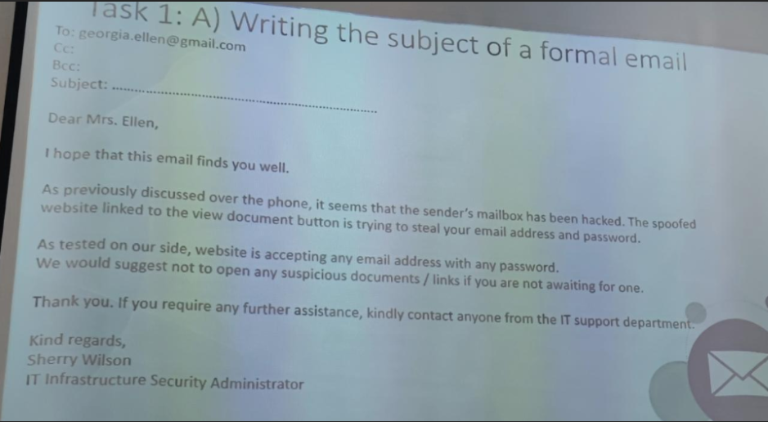

[Solved] Google drive issue or problem

13 octobre : devoir de groupe

[Query]

[Instruction] Spam email

[Request]

05/10/2022

1=Waited

2=Stole

2= Swore

3= read

4=shrank

5= taught

6= had

7= brought

8= gave

9= sent

10= broke

11= rode

Though(O) (tho)

Thought fought

Throughout

Tough (tuf)

Through (threw)

This

Thing

XAIT SWORE

Read

SHRINK

TAUGHT

HAD

BROUGHT

GAVE  
SEND

BROKE

rode

Transition from old to new gadgets

1. What three gadgets do you use most often? Have they changed in your lifetime?
2. Which of your gadgets would you like to update? Why?
3. What modern technology makes your life easier? What makes it a bit more difficult?
4. Computer, headphones, ipad
5. Computer (battery, heavy)
6. Social media, same

Better, faster, stronger

Instant pot

Air fryer

Newcastle English

1004 = half of a car 1 pound each that many books in digital form

Watch the first and second part of this video and tell

Half of the car

Kindle vs books

Ereader/ebook reader vs paper books

Ford model T 1908 20hp 45mph vs Ford gt 2017 600hp 200mph

Computer 1795 dollars

Compact ultraportables, 13-15’, 1000 dollars or less

Mobile phone April 1973 motorola , 1,1 kg, 23cm long, 10 hours to recharge

150 mobile phones, small, light, thin, computer

1rst tur computer Osborn 1 Adam Osborn 1981 1795 dollars

Compact ultraportables, 15 inch, 1000 dollars or less

Mobile phones Motorola Martin Cooper 1973 1,1 kg 23cm long, 30minutes talk time

150 molibe manufacturers, thin,

Liste des verbes irréguliers:

<https://pasttenses.com/irregular-verbs-list>

<https://pasttenses.com/irregular-verbs-list>

07/10/2022

4 pics 1 word

Feedback

Firm

Admin

Bargain

Privacy

Leadership

Cars, mobile phones, books, computer

Look at some sentences about the technologies from the video and guess the missing information. Watch the video again and chexk your answers.

1. Ebook readers: the cheapest version can hold 1400 books in a digital form.
2. Cars: the 1908 model had a top speed of 20 mph. The 2017 model has a speed of 200 mph.
3. Laptops: the first laptop had a 5inch screen and weighed 24 pounds. The new models have 13-15 inch screens.
4. Mobile phones: the 1973 model weighed 1,1 kg and took 10 hours to recharge.

Choose 3 old technological devices/gadgets and find the newest technological devices/gadgets that have replaced them and explain the different features.  
Example:

Kodak camera-largely replaced by the smart phone

Eg Kodak camera had a film of 100 exposures, a smart phone can hold around 10 000 photos (depending on megapixels and storage size)

https://www.pocket-lint.com/gadgets/news/141336-obsolete-technologies-that-will-baffle-modern-generations

Fax machines

The humble fax machine was essentially a modern version of the telegram. For many years, it allowed people and businesses to transmit scanned documents from one phone number to another. The recipient would have the joy of a printed copy of the document bursting forth from their machine. This was all done by a transmission of audio frequency tones that were deciphered at the other end.

Like many of the technologies on our list, fax machines have largely been rendered obsolete by the invention of email, the internet and advancements in computing technologies.

Alexander Bain Il est cité comme l'inventeur de la première machine de fax, breveté 1843

**1971** : Ray Tomlinson

Typewriters

The humble typewriter, the dumb precursor to the modern computer, was in its day a marvel of technology. A step up from paper and pen, the typewriter opened up a world of possibilities for those looking to craft novels, document history or scribe propaganda.

The foundations for the typewriter were laid down as far back as 1575, but it's rarely used in a modern world of computers, laptops and tablets.

Opinion essay to write

Opinion formation

Technology has transformend our world positively in various ways …..

V/S

Technology has changed our world drastically in negative ways…

Helpful phrases:

* I personnaly feel that…
* In my opinion, …
* Based on my experience,…
* I would suggest that…
* I partially agree with…
* Speaking from my perspective …
* From my point of view,…
* Even if this is right, I still think that…

Jade, Loîc, Élisée, Joïce (Technology has changed our world drastically in negative ways…)

Vs

Fitia, Sarobidy, Ethan, Anditiana (Technology has transformend our world positively in various ways)

Lucas, Kim, Manoa, Lando, Shanon

Vs

Nikil, Maeva, Pierre, Angelin,Kevin

Greeting the audience,:

“**Good afternoon, honourable adjudicators, members of the opposing team, chairlady and audience.** **I'm the Captain of the affirmative side.** **Today, our motion is ______________.**” This is the standard greeting.7 avr. 2016

Dear teacher, classmates, friends, a very good morning/warm welcome to all of you

Ladies and gentleman, I would like to welcome you to today’s debate

Introducing the main topic:

Today our motion is

The motion for the debate today is …

Let us start with

Let’s begin with

Presenting main arguments:

* The primary claim that we would like to make is
* We would like to advocate
* The first point that we would like to address /or highlight
* Most importantly, I want to mention that

Research work:

Faire les recherches sur le débat

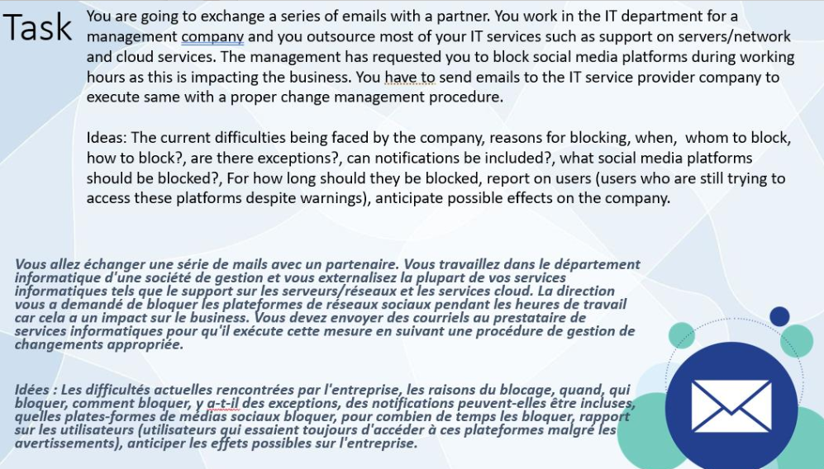

1. Introduce the topic
2. We will have a first speaker (somebody who present the first argument to defend your point) Present the first argument (give examples to support)
3. Someone who will oppose the other teams argument
4. Final freestyle debate
5. Conclusion

12/10/2022

Atypical

Apolitical

Deactivate

Dehydrated

Demotivate

Disadvantages

Disqualified

Misinterpreting(no) Misleading

Misunderstood you

Antibiotics

Antisocial

Distress

Dystopia

19/10/2022

Jeu baccalauréat

Job titles

Reasons to quit your job

Item in an office

Something you should not bring to work

A word related to business

|  |  |  |  |  |
| --- | --- | --- | --- | --- |
| Job titles | Reasons to quit your job | Item in an office | Something you should not bring to work | A word related to business |
| Manager,musician, machine operator, make up artist, machine assembler |  |  |  |  |
| Administrative assistant, accountant, analyst,actor | Assault,age | Alarm, | anaconda | Account, allocation |
| Scientist, sales manager | Sexism, stress | store | spatula | Secretary |
| News reporter, nurse, narrator | New job, narcissism | Notebook, | narcotic | Negotiation, network |
| Electronic operator, engineer | Ego, | Eggplant, eraser, envelop | Elephant,ego, envy, | Economic, ecommerce |

Remote working = télétravail

Warm up

What’s the difference between remote work and traditional work?

Casual clothing vs well dressed

Less interaction vs more interaction

Sleep more, vs sleep less

Office wear, one will need to be dressed according to the work environment

Lack of socialisation, physical contact with colleagues, work alone

Instant communication is possible even for remote work

More family time; sometime no boundary between personal and non-personal time

Traditional work: more company expenses

More focused

More flexibility for remote working

Work anywhere

More time

Reading for the main idea

You are going to read an article about remote working. First skim-read the article quickly to get a general idea of the content and the organisation. Which of these topics is not mentioned in the article?

Benefits for workers +

Benefits to employers

Negative effects +++

Popularity of remote working +

Solutions++++

Type of stress +

Commute = to travel to work (home 🡪 work; work 🡪 home)

The benefits to employers is not mention

21/10/2022

Find a definition for each of the following words.

1. Pitfalls
2. Burn out
3. Millennials
4. Mentality
5. Commonplace
6. Tendency
7. Isolation
8. Detrimental
9. Outweigh
10. Replicate
11. Trap
12. Exhausted, exhaustion
13. Y generation
14. Mind set
15. Ordinary

Correction

1. Disadvantage
2. Extreme exhaustion, overwork
3. Late 1991, uptil 2001
4. Way of thinking, mindset
5. Usual,
6. Habit, trend
7. Being alone, lonely
8. Harming you, disruptive,
9. Surpasser, more than, beyond, greater than
10. Repeat the same thing,

Reading for detail

These sentences have been removed from the article. Read the article again and match each sentence with a numbered gap.

1. And, with no visible body language it is tricky to communicate our true meanings. : 3
2. Employers need to put the right structures in place, such as scheduled video calls and regular team-building meetups. : 5
3. One significant issue was the management of virtual working. : 4
4. Some multinationals have all their staff working remotely, with employees situated all over the world. : 1
5. The benefits are important. : 2

Homework:

Shaping your opinions

Working remotely is more productive than working in the office. Discuss.

(Agree or disagree, or both)

26/10/2022

Pictionary

Opinion

Inquire: investigate, ask for information etc

Pitfalls

Boon = aubaine

|  |  |
| --- | --- |
| Working remotely is more productive | Working in the office is more productive |
| self-disciplined and motivated., less stress |  |
| More flexibility, more autonomous, no commuting, more |  |
|  |  |

Working remotely is more productive: less pressure from the boss, the manager, the authority, less pressure= more relaxed to do your work, more productivity, more flexibility would also be synonymous with productivity. Don’t have to commute (travel to home to work, work to home) saving time, you can work, more balanced life, employees would also have a better mental health, work from anywhere, less expenses, more cost effective (don’t need to pay for an office, can hire more employees),

Working in the office is more productive: distractions at home (children)

Workiign remotely can be less productive as there are and there might be too many distractions such as family, neighbors, surroundings etc

Longer to finish certain objectives,

There are some tasks that would be easily done or better effected on site than online. Some employees would need some pressure to be productive (working at home = too relaxed, need some stimuling)

Fixed working hours whereas when you work at home you might work for more hours, blurring during hours and professional life, lack of motivation, lack of motivation and competition

Technical problems = wasting time, trying to fix those problems, miscommunications, lack of communication because of technical issues.

Eat more, own electricity, prepare more things when you are at home

Topic for Friday class: green technology

09/11/2022

Check little test

Green technology

Word search

Changes energy from a natural source to produce electricity = solar pannels

Energy that is produced from different natural resources instead of fuel= renewable sources

Something that is trying to help nature = eco-friendly

The amount of carbon dioxide that someone’s activities produce = carbon footprint

Can be used for a long time without damaging the environment= sustainable (durable)

Responsible use of computer devices to help the environment= green computing

When a company pretends being eco-friendly for marketing purposes rather really trying to reduce its impact on the environment= greenwashing

What is green technology?

The use of technology to mitigate and reverse the effects of human activities on the environment.

Think of examples of green technologies

Solar pannels

Wind turbine: A **wind turbine** is a device that converts the kinetic energy of wind into electrical energy

Solar Water heater

Electric cars

Led lights = using 85% less energies

Vertical farming

Geothermal energy

What are the benefits of green technologies?

Reduce carbon footprint

Creating a sustainable future

Unlimited

Reducing cost in the long run

Let’s watch the following video (write down your main points):

Sustainable tech

11/11/2022

Nouns

1. Many of my friends disagree with me on this topic.
2. Fifteen pounds is the price of that jacket. (fifteen pounds = unit)
3. Two hundred kilometres seems a long distance to drive just for a party. (1 unit of distance)
4. One-half of the students in the class have good marks on the test. False, it is has because it is a fraction (in English a fraction is singular)
5. Several members of staff in the company need a higher salary. (several members=plural)
6. Neither the bread nor the cheese are fresh enough to eat. Is fresh enough (subject closest to the verbs; either this or = same rule will apply)
7. Two chairs by the table in the dining room are broken. (two chair= plural)
8. Many politicians in public office have concerns about protecting the details of their private lives. (many politicians = they)

Subject-verb Agreement 1

1. Annie and her brothers (is, are) are at school. Correct
2. Either my mother or my father (is, are) is coming to the meeting. Correct (father=singular)
3. The dog or the cats (is, are) are outside. (cats=plural)
4. The man with all the birds live (live,lives) on my street. False; lives on my street (subject=the man who is singular)
5. Nobody (know, knows) knows the trouble I’ve seen. (indefinite nouns everybody, everyone, nobody, no one, anybody , somebody, someone, no one = singular every time for them)
6. There (was, were) were fifteen candies in that bag. Now there is only one left. (candies = plural; one=singular)

20% of the gasses we breathe are oxygen. Gasses is in plural form (the verb after the percentage is in plural so it is in plural, we need to look at the noun after the percentage)

Collective noun, the crew = group of people, group like family= singular; the crew is on board already, they are on board.

Only one of the dogs has ever had a vaccination. Correct

Adverbs

Adverb = adding to the verb

I am walking. = no adverb

I am walking quickly. = adverb, quickly is adding information.

Sometimes an adverbs add to an adjective (she is very pretty; very = adverbs)

Identify the adverbs from the following:

* Enjoy the spring of your youth now because time passes rather quickly. (Quickly, now(information about time), rather (plûtot) = adverbs)
* Like wing, life oozes ceaselessly from our cups; like falling leaves, life floats daintily away from our grasp. (ceaselessly( sans cesse ) , daintily (délicatement), away = adverbs)
* There is only one way to live: graciously appreciate the present! (only, Graciously = adverb)
* The journey of life continues forward; do not worry needlessly about the future. (needlessly (adding to worry), forward (adding to the verbs continues) = adverb)
* Today you should enjoy the fruits of life: music, leisure and love! ( Today = adverb)
* We can hardly believe what the future brings until we experience it ourselves. (hardly (à peine), until = adverbs)
* We are quite surprised by our inability to change the past but our actions cannot be reversed, so choose your path wisely. (Adverbs= quite,wisely (sagement))

Identify mistakes from the following sentences 5read the following quotes ond try to spot the mistakes☺

* The nice thing about being a celebrity is that when we bore people, they think its their fault.
* Big jobs usually go to the men who prove there ability to outgrow small ones.
* Never interrupt you’re enemy when his making a mistake.
* It’s never to late to be what you might have been.

It’s (its= son, sa) (it’s = it is) ,( .)

Their

Your, he is or he’s,

Too (trop), what you are (we remove might have been)

: colon

Sca Category (baccalaureat)

|  |  |  |  |  |
| --- | --- | --- | --- | --- |
| Brands | Adjective | Any word related to IT | A professional skill (competences) | Job titles |
| Miniso | Misused (no, verb) | Marketplace | Manage | Manager |
| Taco bell, tesla | Tempting, tall | technology | Tactful, teamwork | Teacher, trainer, truck driver |
| Air Jordan,apple, almost, Adidas | Accumulative, ageless, attractive, adequate, | Account, adapter | Accurate, agile, ambitious, analytical | Aviator, Analyst, Actor |
| Snickers, sketchers, subaru | Small, salty, short, savage | Screen, system, software | Socia, smart | Seller, salesman, steward |
|  |  |  |  |  |

185

95

94

40

39

34

32

10

16/11/2022

Vendredi 18/11/2022: test d’anglais sur écrire un email et vocabulaire (avec des phrases à faire)

Let’s watch the following video (write down your main points) :

To conclude ; sum up

30/11/2022

Part 1- Interview skills

Have you heard any strange interview stories? What was it?

Have you attended many job interviews? How do you prepare? What’s the most difficult part of the experience?

I have once seen a youtube interview, someone called Greg guillautin, it was a hidden camera prank. He was acting strangely and doing some weird things like coming to the interview with a shirt. More over he was using the informal language, he was acting like he was already hired and asking for a huge salary.

Prepare: do some researchs about the company so you know exactly what they do, it can be a bonus,

The most difficult part is to sell yourself

Present yourself: when you are ask to present yourself don’t say what’s already in the cv. “During my diploma I have acquired these skills”

Most difficult part: questions “why do you want to work here” : you have to say what this company is going to give you in return, what you will learn about this company, what skills you want to acquire, the more specific you are it shows you are intelligent, you have done your research’s.

Why do we have to choose you instead of someone else: you have to use 3 powerful words; 3 strength that you have, the skills required (determinate, analytical, passionate); If you hire me I will be very determined, I will make sure that the goal of the company will be achieved, surprised the interviewer. Initiate.

To present myself I want to cover 3 main points: My study background etc …

Show confidence but also take the initiative; you should ask questions at the end of the interview

The questions you can ask the interviewer at the end of the interview: Is there any way that we can involve in the company; are there any prospects for this job? I would like to know about the salary range.

How much do you like to earn: I know that there is a salary range that has been decided by the company; I would like to know the range so I can decide if it’s

Give a range, never give a fix amount

Nerve-racking (énervant)

1. If a situation is Nerve-racking , it causes a lot of stress. Nerve-racking
2. If something in your mind sticks out , you remember it very clearly: sticks out (sortir du lot)
3. If somebody makes you do something against your will, you do not want to do it: against your will. (volonté)
4. If something is nationwide, it takes place all over the country: nationwide.
5. If a company is hiring for a position, they are looking for a new employee: hiring for (recruiter)
6. If you are the perfect fit for a job you are the best candidate to fill the position: fit for
7. Mind mapping your personality for an interview
8. What are some of the positive traits that an employer looks for? (your strengths and weaknesses)
9. Your past work experience
10. Background information of the company
11. What can you do for the company?

02/12/2022

Do not use the word “problem” in an interview, choose the word “challenge”, it’s better.

Climb the ladder

Describe your dream job: I would like to have the prospect to climb the ladder and maybe one day to join the top manager because I’m interested in leading, managing etc…

Where do you think you will be in 5 years: In 5 years time I think I would have accomplish certain project, I would have led certain projects for the benefit of the company, I

Tell me about yourself: I liked to cover 3 major points: talk about your bac, echesy,

Work experience:

Tell me aobout yourself!

Cover 3 major points:

1. Your recent educational accomplishment
2. Recent work experience
3. Your main professional interest/goal – reasons why you are interested in this position
4. Anything unique about you that is not on the CV but could be of interest for the job.

Invent a little bit: I have help my parents, my father, my mother, my uncle in whatever jobs they have, administrative work

Using your talent

Interviewer-Interviewee

Answer random questions:

* Out of all the candidates, why should we hire you?
* Describe your dream job.
* What kind of work environment do you like best?
* What is your leadership style?
* What can we expect from you in your first three months?
* What do you like to do outside of work?

Help me to clear my mind, think better after swimming

Part 2- Job application

What documents do you need to apply for a job?

Cover letter, reference letter, CV, qualifications, copy of certificates, diploma, proof of address. Character certificate (casier judiciaire)

With your friend, decide if the following statements are true or false

1. A CV is a document with information about you. True
2. You use a CV to get a job. True
3. You should put your photo on your CV. False, because of discrimination
4. Your CV should be 3 or 4 pages long. False, only 1 page
5. It’s OK to have mistakes (spelling, grammar …) on your CV. False
6. All information on your CV must be in full sentences. False best if it is brief
7. Employers usually look at the CV for about 2 minutes. False, less than 2, 40 seconds-60 seconds.

Google scholars

Attractive the CV, need to be attractive

Multiple intelligence test

List the different parts of a CV

1. Personal details
2. Educational background) Education and qualification
3. Work experience
4. Skills (language skills)
5. Interest
6. References
7. Personal details
8. Education and qualifications
9. Work experience
10. Skills
11. Interests
12. References

Career objectives at the top of the CV for English speaking countries

Writing an objective in a CV

What are your main skills and your ultimate professional goal?

Seeking a challenging position in a well-known organisation in order to further develop my analytical, managerial or leadership and interpersonal skills.

I would like to improve the life of people through my skills in the IT sector.

Seeking to improve my skills in the IT sector I want to find a way to improve the lives of people using new technology.

In order to further develop my collaborative skills and awareness of the field

My awareness of web development and interpersonal skills so as to create or to launch my own business in the future.

GOOD: Seeking to improve my skills in the IT sector I want to find a way to improve the lives of people using new technology.

Interest : in line about your field, continuous development , leisure reading, pleasure reading

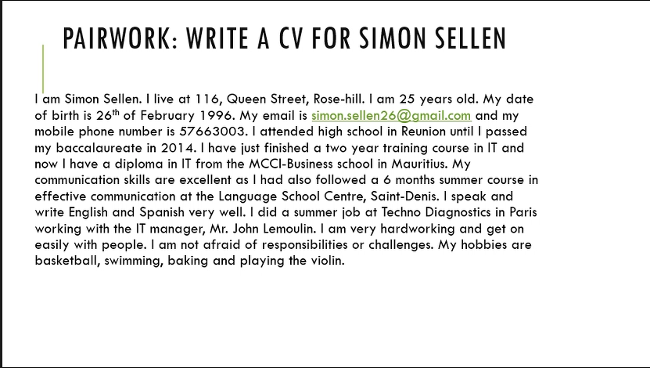

09/12/2022

Cybersecurity and cybercrime

To encrypt: le processus consistant à transformer

Hack :

Cybercrime :

Credit card fraud

Ramsomware

Hacktivism

Using the vocabulary words above, complete the following sentences (remember to use the correct form of the word, e.g. verb conjugation or plural noun)

1. All email and messages should be encrypted to prevent confidential information being compromised.
2. Cybercrime in the UK in 2020 resulted in losses of £414 million for the banking industry.
3. In 2015, hackers from Anonymous revealed the personal details of nearly 1,000 members of the Ku Klux Klan.
4. It was revealed this week that JBS Holdings had paid $11 million to cybercriminals who had infected their systems with a ramsomware.
5. Panamanian law firm Mossack Fonseca suffered a hack which resulted in more than 10 million confidential documents being leaked to the public concerning offshore companies.
6. Police forces across the world are having to rethink their strategies to combat cybercrime/hacktivism.

Pairwork: Answer 3 of the questions below:

1. Can you think of any well-known cyberattacks? What happened? What was the consequence?
2. What kind of files do you need to encrypt at work?
3. Have you, or anyone you know, been a victim of cybercrime? Who did/would you report it to?
4. Why are banks reluctant to report credit card fraud to the police?
5. If your system becomes infected with ransomware, is it better to pay the ransom or not?

1. RockYou2021: The biggest password leak yet – 2021

The largest stolen password collection of all time saw 8.4 billion passwords leaked.

The hacker – whose identity is not disclosed – named the password compilation “[RockYou2021](https://gurucul.com/news/biggest-password-leak-ever-8-4-billion-passwords)”, referencing [the 2009 RockYou data breach](https://techcrunch.com/2009/12/14/rockyou-hack-security-myspace-facebook-passwords/), in which more than 32 million users had their passwords harvested.

The password hacker posted a 100GB txt file containing 8.4 billion password entries, alongside previous data leaks.

2. Confidential informations

Account details

Password

Transactional details

In the academic word, assessment field MES

Reputational risk,a lot to loose

1. Ramsomware should not be paid, not sure

Hobbies: corporative skills, collaborative skills

Time management skill

Form part in an orchestra

Others should be more visible than the skills

14/12/2022

Wrist= poignet

Feature: an important part or characteristic:

Feature:

Customers

Consensus

Strategy

Authorisation

Innovation

Infrastructure

11/01/2023

Ecommerce

Act 1

Think-pair-share

Do you shop online? Why/Why not?

How popular is online shopping in your country? Which websites are popular?

How safe is it to shop online? Why?

Yes, More facilities, no need to go to the shops

It is developing and diversifying. Amazon, alibaba

Shoes, clothes

More accessible, compare the prices

Responsible, official websites, https, method of payment, report fraudulent account on facebook

Ghj

Complete the definitions below with the following words:

**Booming, broadband, in bulk, secure, tech-savvy**

1. Tech-savvy (féru de technologie) (adj): avoir une bonne connaissance pratique de la technologie
2. Booming (en plein essor) (adj) : très réussie e.g business is booming
3. Secure (sécurisé) (adj): ne pas être accessible à une personne non autorisée
4. In bulk (en masse) (phrase) : en grand nombre ou en volume
5. Broadband (noun) : un système de communication utilisé pour un accès internet à haut débit.

Try to answer the following questions on your own. We’ll check your answers later.

1. When was the first product sold online? 1994
2. What was it? A cd
3. How much were global internet sales worth in 2000? 800 million pounds
4. How much were global internet sales worth in 2007? 250 billion pounds
5. How many people use the internet today (2007)? Almost 2 billion

Consumers: consommateurs; available: disponible

Word search find the words from the article based on the following definitions

1. Experiencing (a change) (verb ing, P1) undergoing (subir)
2. A temporary period of very successful economic performance (noun, P2) bubble burst
3. Space in a shop to display products (noun phrase, P3) shelf (étagère) space (espace de rangement)
4. A great and sudden increase (noun, P5) proliferartoin

Retailer: détaillant, vente au détail

Wholesaler: grossiste

Catwalks : passerelle

Read the article and complete the following table

|  |  |
| --- | --- |
| Advantages of online shopping | Advantages of traditional shopping |
| Unlimited choice  Huge global shopping marketplace (more accessibility and availability)  Find the cheapest retailer online (competitive)  Different platforms internationally  Items delivered anywhere (convenient, practical)  Easier to buy in bulk and get it delivered | Best selling products available  Better to buy personal product  Personalize shopping, see if it suits your requirements  Pleasure of shopping  Plan a future purchase |

Summary compte rendu d’article en français, 2 eme partie essay writing

13/01/2023

Read the following sentences from the text :

1. The retail industry is undergoing a revolution : present continuous
2. Websites will become more sophisticated. future
3. By the time of the dotcom gold rush in 2000, Internet sales had reached 800 million pounds a year. Past perfect tense
4. E-commerce sales have exploded since 2000. Present perfect tense

Which sentence above describes:

1. A trend that started in the past and is complete in the present? d
2. A trend that is in progress at the moment? a
3. A trend that was completed before a particular point in the past? c
4. A predicted future trend? b

Past perfect : had + past participle = had eaten

Present perfect tense : has or have + past participle = has eaten (he/she/it) or have eaten

Past Present Future

Past perfect Simple past tense(ate) Present perfect tense I eat will

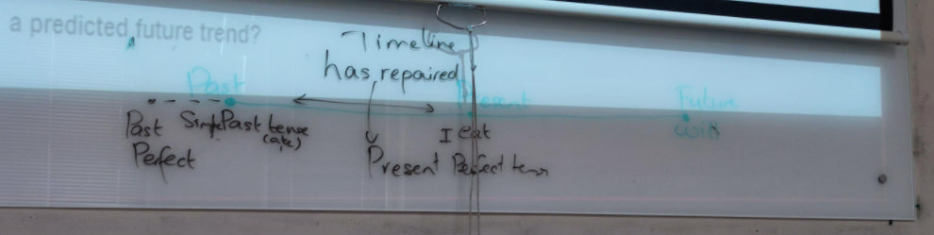

Grammar review

Now form complete sentences, putting the verbs into the correct tense:

1. At present/ sales/ increase/ rapidly : At present sales is increasing rapidly
2. By the end of the last quarter/ our profit/ fall/ by 12% : By the end of the last quarter our profit had fallen by 12%
3. The number of online subscribers/ reach/ 2 million/ since we started the business : The number of online subscribers has reached 2 million subscribers since we started the business (since : present perfect)
4. At the end of this year/sales/reach/$1m: At the end of this year the sales will reach $1m
5. Interest rates/drop/by 2%/over the last five years: Interest rates have drop by 2% over the last five years (present perfect)
6. More and more people/work at home/these days: More and more people are working at home these days.
7. The population of the island/reach/2 million/ in 1999: the population of the island reached 2 million in 1999.
8. Turnover (chiffre d’affaires)/ not change/since the company relocated to Germany: Turnover has not changed since the company relocated to Germany.
9. Next year/consumer spending/ go up/ dramatically: Next year consumer spending will go up dramatically
10. By the time he was ready to expand the business/he/spend/$2 million/on advertising: By the time he was ready to expand the business he had spent $2 million on advertising.

18/01/2023

|  |  |
| --- | --- |
| Informal words | Formal words |
| To set up | establish, configure |
| To put off | Delay, differ, postpone |
| Seem | Appear |
| To say no | Decline, refuse, turn down, reject |
| Worse | Substandard, unfavourable, inferior, impoverish |
| To tell | Inform, notify |
| To use (a product) | Utilize, employ, consume |
| To shorten | Reduce, curtain, abbreviate, decrease |
| Mainly | Principally |
| Lack | Deficiency |
| Empty | Vacant |
| Lucky | fortunate |
| Give | Offer, bestow, to provide |
| Buy | purchase |

Telephone conversations

Business Communication

Pair discussion question:

* Have you ever spoken in English with someone on the phone? With whom was it?
* How do you feel when you speak in English on the phone?
* How often do you speak on the phone in English?
* How can you become more confident talking on the phone in English?

Time for some vocabulary!

Complete the phrasal verbs with words given below.

* Slow down: to reduce the speed at which something happens, e.g. you speak
* Think through: to carefully consider the possible results of doing something
* Hang up: to end a phone conversation
* Write down: to record information on paper
* Freeze up: to be enable to think of anything to say, especially because you are nervous.
* Calm down: to begin to feel more relaxed and less emotional

Trouvez l’équivalent formel de ces répliques informelles

|  |  |  |
| --- | --- | --- |
| PURPOSE | INFORMAL | FORMAL |
| Answer the phone | Hello/Hi | Good morning/afternoon/evening  Hello this is Andy from itech limited speaking, how may I help you? |
| Ask for someone | Is Josh there ? | Can I please talk to Josh? I would like speak to Mr Josh/ Could I speak to Josh please? |
| Identify yourself | I’m Tamara | This is Tamara |
| Ask for caller’s name | Who’s this ? | Could you please tell me who I'm speaking with? May I ask who's calling? Would you mind telling who's talking?  Who’s calling please ? |
| Ask someone to wait | Hang on a minute | Give me just a moment please  Best: Please hold on a moment |
| Say you will try to make the connection | I’Il get him | I’ll pass that on to him |
| Say someone is not available | Sorry. He isn’t here. | I’m afraid he is not available right now |
| Offer to take a message | Can I take a message for you? | Would you like to leave a message? |
| Leave a message | Can you tell him that I called? | Would you kindly inform him of my call |
| Checking if the person has understood | Have you got that? | Would you like me to repeat? Would you like me to say that again? |

20/01/2023

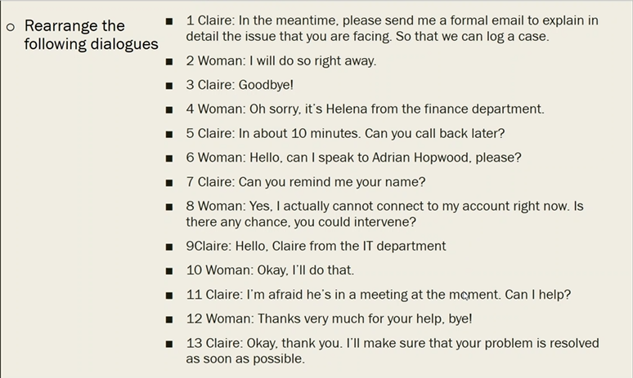

9;6; 11;

9; 6;11 ; 8; 5; 10; 1; 2; 7; 4;13; 12; 3

9-6-11-8-5-10-1-2-7-4-13-12-3

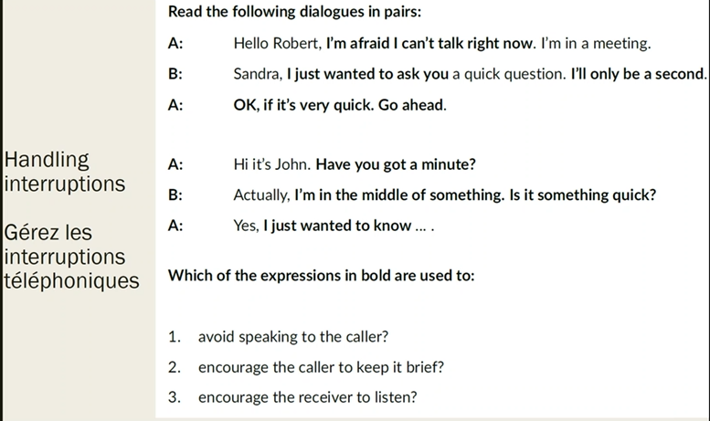

1. I’m afraid I can’t talk right now/ I’m in the middle of something/ I’m a bit busy at the moment/ Can I call you back later?/ Is it something urgent?/
2. Ok, if it’s very quick. Go ahead/ Is it something quick?
3. I just wanted to ask you/ I’ll only be a second/ Have you got a minute?/ I just wanted to know/ This won’t take long/ I be really quick

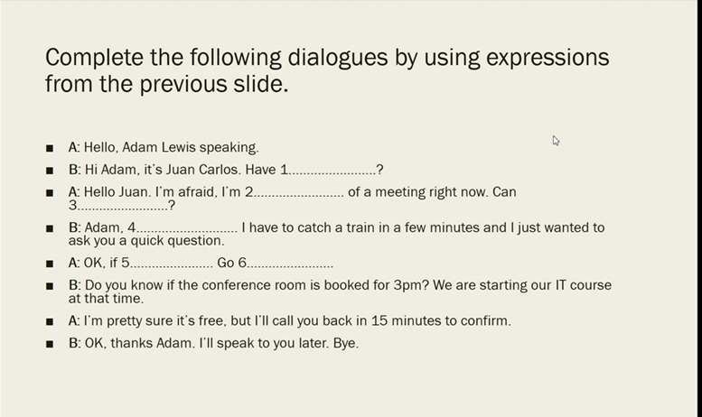

1= Have you got a minute?

2= I’m in the middle of a meeting right now

3= Can I call you back later? Can you wait?

4= I be really quick/ I’ll only be a second

5= If it’s very quick

6= Go ahead

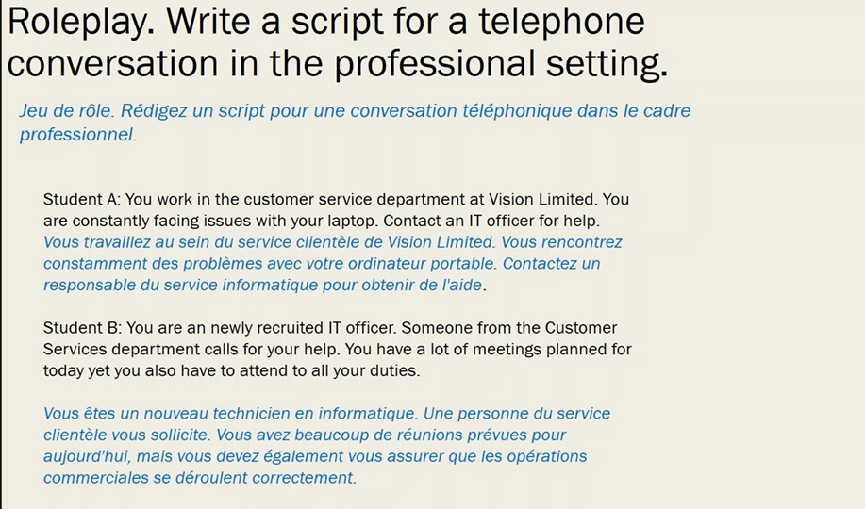

03/02/2023

Antonyms

Extreme/ moderate

Find / Lose

Background (arrière plan) / Foreground (avant plan)

Many/ none or few

Break/ repair or fix

Foreigner/ native or local

Immigrate/ emigrate

To follow/ lead

Bad luck/ fortune or blessing

Entrance/ exit

Unity/ division

Attack/ defend or defense

Accidental/ intentional

Different / similar or alike

Modern / ancient or traditional or old fashioned

Simple/ complex or complicated

Approximately/ precisely or exactly

Constant/ variable or changeable or inconstant

Types of intelligence:

Artificial intelligence

Emotional intelligence

Multiple intelligence

Musical intelligence

Interpersonal intelligence

Linguistic intelligence

Artificial vs human intelligence

Put these technological developments in order from 1 (most likely to happen soon) to 6 (least likely to happen soon).

1. Electric aircraft
2. Colonisation of the moon
3. Drone mail deliveries
4. Cashless economies
5. 3-D printed furniture
6. 100% synthetic food
7. 3-d printed furniture
8. Cashless economies
9. Drone mail deliveries (launch by amazon)
10. Electric aircraft
11. 100% synthetic food
12. Colonisation of the moon

Think-Pair-Share Activity

Will artificial intelligence replace human intelligence? Why?

Increase, enhance but not replace

Humanoid roboot (Sophia)

Train the robot, makes the robot

Creativity, ability to do more might decrease

Wally movie

Complete the phrases with prepositions

1. In terms of technology
2. The impact on business
3. At The expense of jobs
4. The barrier to entry
5. Poised for a rapid increase
6. Valuing artificial intelligence over human intelligence
7. As we head into the 2020s
8. Put power in people’s hands

Complete the table using vocabulary from the text.

|  |  |
| --- | --- |
| Verb | Noun |
| Innovate | Innovation |
| Recognise | Recognition |
| Develop | Development |
| opt | Option |
| Adjective | Noun |
| Unequal | Inequality |
| Bold | Boldness |
| Dry | Drought or dryness |
| stable | Stability |

**If you can put the word the in front of a word and it sounds like a unit, the word is a noun**

The , a , and in front of noun

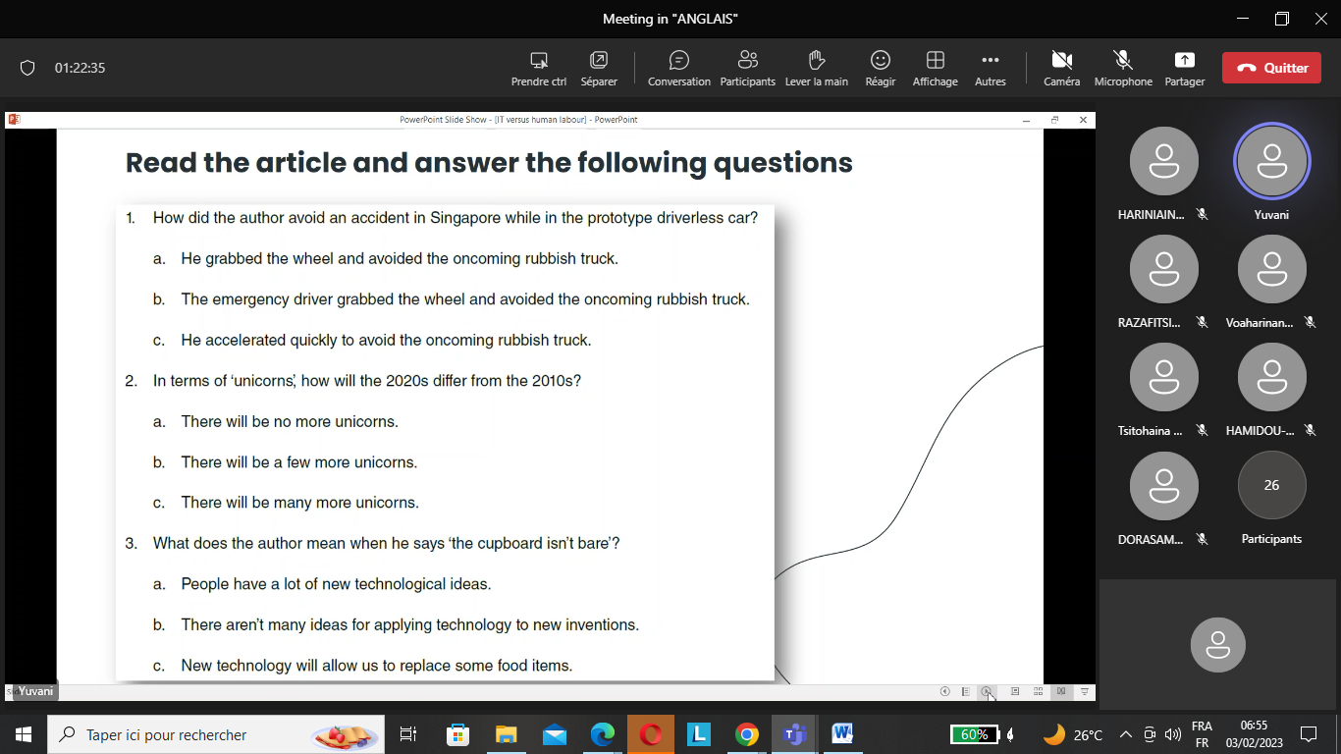

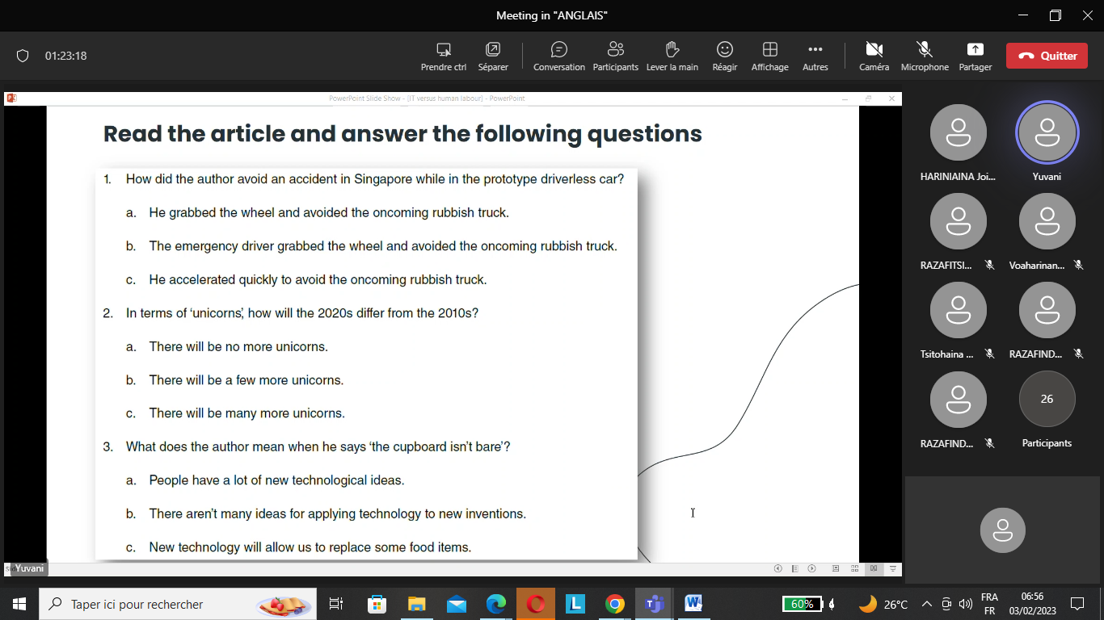

1.b

2. c

3.a

4.a

5.b

6.b

1. How did the author avoid an accident in Singapore while in the prototype driverless car?

a. He grabbed the wheel and avoided the oncorning rubbish truck.

b. The emergency driver grabbed the wheel and avoided the oncoming rubbish truck.

c. He accelerated quickly to avoid the oncoming rubbish truck.

2. In terms of 'unicorns, how will the 2020s differ from the 2010s?

a. There will be no more unicorns.

b. There will be a few more unicorns.

c. There will be many more unicorns.

3. What does the author mean when he says 'the cupboard isn't bare'? (cupboard = placard) (bare=empty)

a. People have a lot of new technological ideas.

b. There aren't many ideas for applying technology to new inventions.

c. New technology will allow us to replace some food items.

4.What could happen if artificial intelligence was prioritised over human intelligence?

a. Automation would lead to massive job losses.

b. Technology would bring huge rewards for shareholders.

c. Nearly half the factories in the US and UK would have to close.

5. How would high unemployment affect national balance sheets?

a. Populist movements would gain support.

b. There would be less revenue from income tax and higher welfare costs.

c. People would believe that the economy was no longer working for most people.

6. According to the author, what will people need to create wealth and power in the future?

a. access to land

b.money to invest in factories

c. innovative ideas that rely on technology

1. Read articles
2. Reperée les idées principales
3. Identifiez la nature du texte
4. La source
5. L’auteur
6. La date de parution
7. Le paratexte
8. Éviter les details inutiles
9. Éviter les exemples
10. Is this really important or can I remove it?

Language 3.5/5

Content 4/5

Moving from technological development to economy to political etc

There are various technological ideas (the cupboard isn’t bare)

Technology is there as an instruments to achieve their goals

To deploy = to use

Surging welfare costs = increasing

Welfare = bien-être

Boldness = audacité

Execution = applicate, operate

Intent = goal, objectives

Write about the main ideas in French, reformulate the principals ideas

10/02/2023

|  |  |
| --- | --- |
| Toutefois | However/ Even though/ Although |
| Contrairement à | Contrary to/ On the contrary/ Unlike |
| Selon | Accoding to/ in the opinion of |
| En accord avec | In accordance with/ In agreement with/ In line with |
| Premièrement | Firstly/ Primarily/ First of all |
| Autrefois | Previously/ In the past |
| Etant donné que | Given that |
| Certe | Certainly |
| Cependant | Yet |
| Notamment | Especially/ notably |
| Ainsi | Thereby/So/Thus/Therefore/ Hence |
| Toujours est-il que | Nevertheless/ |
| Quand à | As for |
| Pour la plupart | For the most part/ Mostly |
| Au lieu de | Instead of |
| Au préalable | Previously/ Beforehand |
| En dépit de | Despite that/ In spite of |
| Tandis que | While/ Whereas |
| Particulièrement | Particularly |

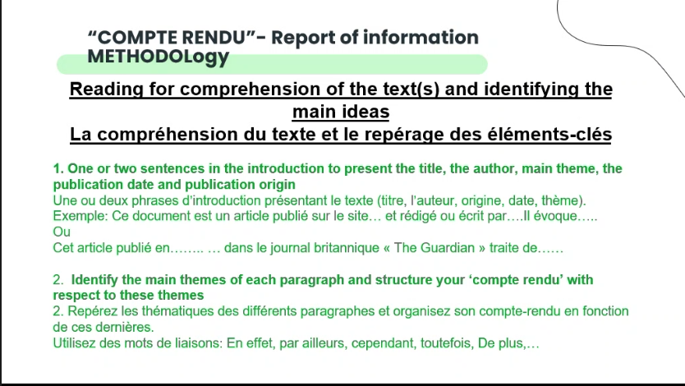

Need to write different paragraphs and not just one paragraph

Report = compte rendu

Use linking words

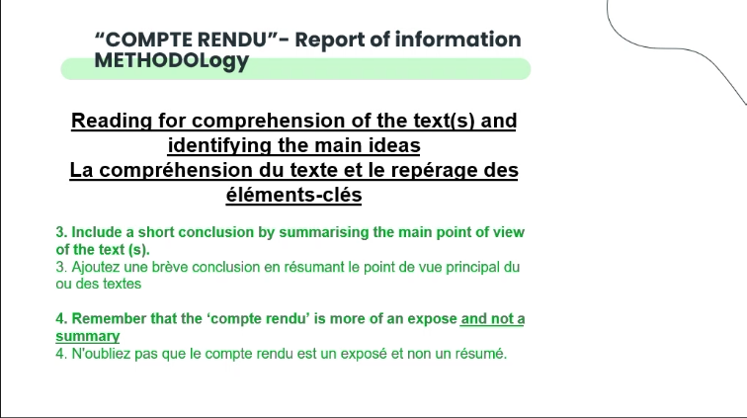

Find the conclusion of the author

“L’auteur mentionne”, “Il est dit”, “Selon l’auteur »

Compte rendu = plus qu’un exposé qu’un summary

!!!!!!!!!!!! Don’t translate word by word !!!!!!!!!!!!!!!!!!!!!!

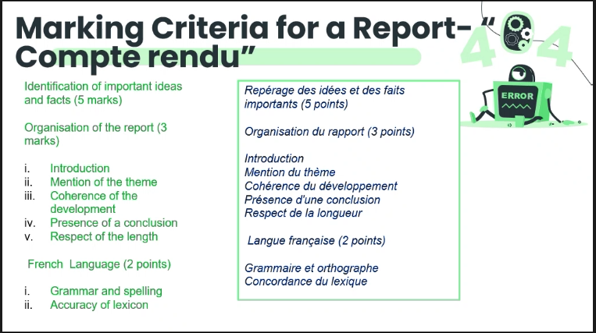

190-210

-10%;+10% toléré concernant le nombre de mots requis

Ce document est un article publié dans un quotidien économique et financier britannique « The financial times » écrit par Leo Johnson et publié le 14 mars 2019. Il évoque les différentes innovations technologiques ainsi que l’impact que l’intelligence artificielle pourrait avoir sur nos vies.

L’auteur fait mention notamment de l’impact qu’aura la technologie sur vos vies, en effet la technologie entraînera un impact économique, social et enfin politique. De plus pour les années à venir, les innovations technologiques ne vont pas connaître un ralentissement, au contraire plein de nouvelles innovations verront le jour et cela sur une courte durée.

De plus il est fait mention des différentes directions que peut prendre ces impacts, en effet avec l’intelligence artificielle qui devient de plus en plus performante, il y a une possibilité que les investisseurs et les entreprises privilégient les robots aux humains. Cela aura pour conséquence un coût de vie plus élevé ainsi que des recettes moins élevés pour l’état étant donné que les robots ne payent pas de taxe contrairement aux humains. Mais il est également possible d’utiliser l’intelligence artificielle à bon escient, en effet avec l’essor de la technologie les barrières à l’entrée des moyens de productions deviennent moins importantes.

Pour conclure les innovations technologique impacteront le futur, le choix est entre nos mains afin de les utiliser à bon escient.

15/02/2023

Presentation skills theme : virtual communiaction

Match the terms on the left to the corresponding definition

* The metaverse: un espace de réalité virtuelle dans lequel les gens interagissent entre eux.
* Virtual reality/ VR (noun) : une expérience simulée générée par ordinateur, avec laquelle une personne peut communiquer à l’aide d’un équipement spécial.
* Augmented reality/AR (noun) : est l’intégration des données numériques dans l’environnement de l’utilisateur en temps réel.
* Avatar (noun) : la représentation informatisée d’un utilisateur

Think-pair-share

Do you prefer to make friends in the virtual world or in the real world? Why?

What makes a good presentation?

**Preparation**

* Preparation is one of the most important parts of delivering an effective presentation and it can also help to control the nerves - you can never over-prepare!
* Consider your audience and their background, this will help you to decide on the content and style of delivery.
* Estimate the time available for your presentation so that you can decide on how much information you can include. Be realistic about how much material you can cover as it is important that you keep within your time limit.
* Before putting your presentation together, you must define the aims, topic and appropriate depth and scope of the information you will be presenting.
* Collate all the information and ideas and organise them in a logical sequence. Remember that the presentation is telling a story and this must be clear and logical to the listener.
* Structure your presentation. Typically, oral presentations have three main stages:  
  - The introduction: (what you intend to say)  
  - The body (the presentation itself)  
  - Conclusions (what you have said)
* Know the subject thoroughly. Check all the work for clarifications and think about what questions the audience might ask. If you are unfamiliar with your subject you will feel uncomfortable with it, and nervousness will increase. Learning as much about the subject as you can will help boost confidence in delivery. It also improves flow and helps with questioning.
* Ensure that your presentation includes definitions, any underlying assumptions, historical background or any other introductory material. The amount of introduction you need will depend on your audience.
* If you are reading from notes in your presentation, be sure to use key words and phrases in your notes rather than sentences. This will prevent you from reading directly from your notes and help you establish eye contact with the audience.

**Preparation of Visual aids**

* If used in the correct way, visual aids (such as OHP's or Powerpoint slides) can greatly enhance your presentation. They can be used to highlight key points and display images or diagrams.
* It is important that your visual aids clarify and support your data in an attractive and comprehensive way. They should not detract from your presentation.
* Ensure that you only write down the key points in your slides. Try not to present long and detailed sections of text. Bullet points can often be more effective and the audience will be able to concentrate on what you are saying rather than reading the slide (4-5 bullet points are an acceptable amount per slide). These bullet points can also be used as prompts/cues for your talk. Do not use too many gimmicks such as 'flying text' or noises
* Font size should be large enough to be legible to be seen from all parts of the room (e.g. 22 - 28 for the text and 34-40 for titles.)
* Pictures/diagrams must also be clear, legible and large enough to be seen from all parts of the room.
* Arrange images with plenty of space surrounding each item so as not to clutter your slides/OHP's
* If possible use only one typeface. Too many typefaces can look messy and confusing, particularly if they are in the same sentence or paragraph. Experiment with available styles and find one that you can read from a distance. For emphasis you could always use bold face, italics or colour.
* Use caps and lowercase instead of all caps for easier reading.
* Colour can be used for emphasis, distinction and clarity. Highlighting headings and key points, graphs and charts is a good functional use of colour. However, you must be careful that the colour does not interfere or detract from the visually presented information.
* Be careful with coloured backgrounds as some colours can make black text or figures less distinct. A good tip is to use background and foreground colours that complement each other and have high contrast.
* Prepare visual aids that can be used in the speaking environment. There is no use in preparing a Powerpoint presentation if there is no computer to run it on. Find out in advance what equipment is available to you.

**Practise**

* Rehearse the talk as much as you can. It may help to do a 'dry-run' with a friend or colleague who can then give you honest and constructive feedback
* Time the presentation
* If you are using notes/cue cards, practise your delivery. The more familiar you become with them, the less you will need to look at them.
* Anticipate any questions that could be asked and prepare possible responses. Prepare for the questions that you may not be able answer and know how you will respond to them.

**Delivery**

* Greet the audience and try to look confident and relaxed - smile!
* Wait for the audience to focus their attention on you before you start
* Begin by introducing yourself (and your colleagues if you worked with others). State the topic clearly and give an outline of what you will cover.
* Use your visual aids to highlight the main ideas as you progress through the presentation.
* Stand to the left or right of the screen; make sure you are not standing between the image and your audience. Face the audience as you speak and take care not to turn your body away from them. Try to maintain eye contact with the audience, but don't just stare at one person!
* If you get nervous, take deep breaths and use natural pauses in the content to regain control. Remember that everyone feels nervous at times and the audience will make allowances.
* Don't rush through the presentation and the series of visuals so fast that the audience becomes confused.
* Use your voice by changing volume, pitch and by using pauses to indicate that you are moving onto a new point. Vary your intonation for statements, questions and emphasis.
* Conclude by summarising the main points of your presentation. Reinforcing the main points, both verbally and by repetition, will help your audience assimilate the information.
* Try to answer questions simply and directly. Virtually no one has all the answers all the time and if you don't have the answer, say so. You can, however, offer a helpful solution such as, 'I'm afraid I'm not familiar with that topic, I'll find out and get back to you'.

Tone, articulation, hand gestures, body movement, good knowledge (researching, reading more on the topic)

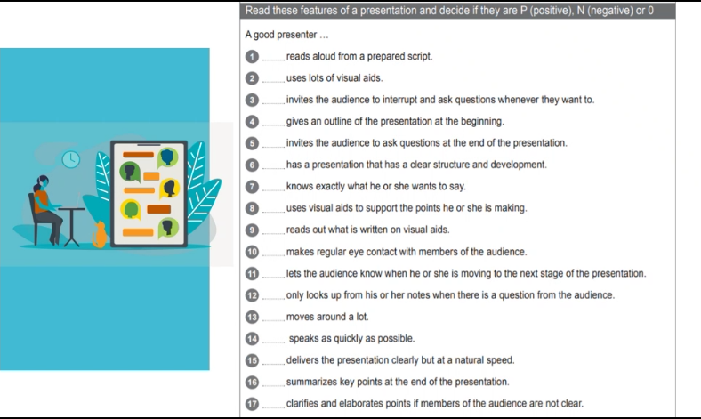

Outline = sommaire

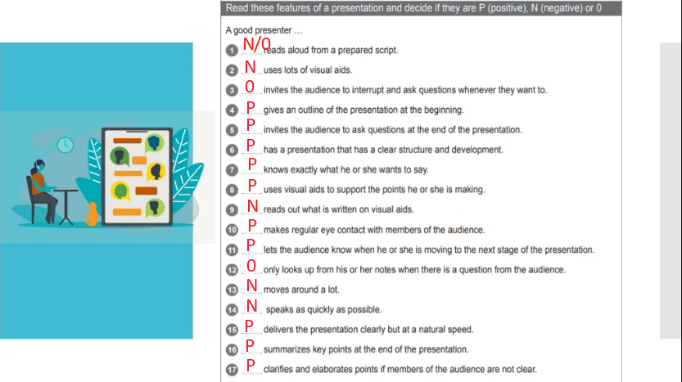

17/02/2023

Listen to the speaker’s introduction and put these into the correct order:

* 1 the current product range
* 2 the future prospects for the company
* 3 the history of the company
* 4 questions
* 5 new products

Answer in this order:

3 The history of the company

1 the current product range

5 new products

2 the future prospects for the company

4 questions

Further = additional

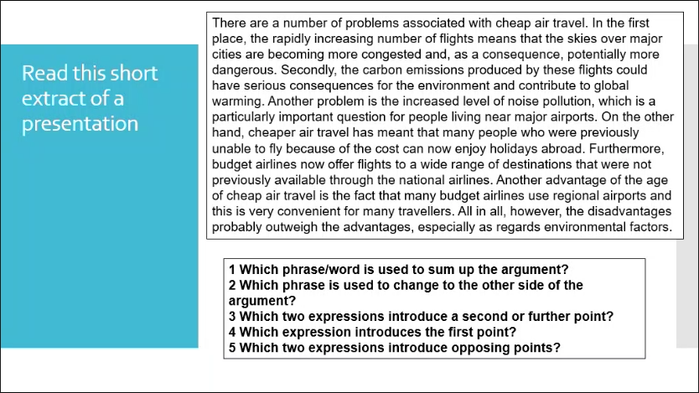

* 1. All in all ( a way to summarize, en un mot, tout compte fait)
  2. On the other hand
  3. Secondly, Further more
  4. In the first place
  5. On the other hand, however

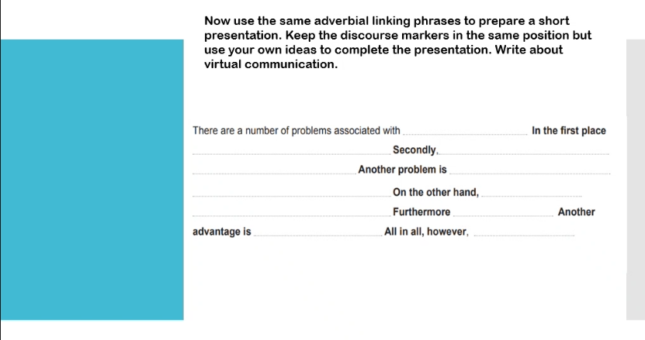

There are a number of problems associated with **virtual communication**. In the first place **it can create some addiction to social media**. Secondly, **people can impersonate you**. Another problem is **that virtual communication can create communications problems in real life**. On the other hand, **it is easier to keep in touch with family or friends who are abroad**. Furthermore **it allows you to communicate information quickly and easily**. Another advantage **is that you can continue to work with several people online**. All in all, however, **virtual communication has positive points as long as there is a moderate and accurate use**.

22/02/2023

I) Opening section

* 1. Greeting the audience
     + For example: Good morning, good afternoon, good evening, Let me first thank all of you for coming today or it’s a pleasure to welcome you all today or a warm welcome to all of you for your presence today
  2. Presenting yourself,
     + for example let me introduce myself, I am …
     + I am responsible for or I am in charge of
     + As you might be aware, I am here in my function as the IT officer/….
  3. State the topic
     + For example: the aim of my presentation today will be to talk about …. Or discuss ….
     + Or in today’s presentation, I will focus on …
     + The topic of my presentation will be/is
     + In this presentation, I seek to explore the issues of education/…
  4. Highlight the importance of the topic
     + For example: by the end of this presentation, you will have a better understanding about …
     + My presentation would be of particular interest especially for all of you who …
     + This issue is of utmost(very) importance because …
  5. Offer an outline of the presentation
     + For example: In this presentation, I will first …
     + Secondly I will …
     + After that I will …
     + I will then move on to the next point which is …
     + Finally I will …
  6. Indicate the duration of the presentation
     + For example: today’s presentation will not last for more than 10 minutes
     + The first section of the presentation will be for about 8 minutes, I will then allocate two to three minutes for Q and A (question and answer)

II) Development section

1. Elaborate on the subject/topic
   * Relevant details should be presented on the topic by answering the following question (WH question How, what, when, where, why, who)
2. Provide examples to support the main ideas (make sure that the examples are simple and short)
3. Use statistics or refer to experts on the subject
4. Make sure that your arguments are well balance ( you have to consider different perspectives on the subject)
5. Use linking words to connect your ideas

III) Concluding section

1. Summarise (summarize = american) the key point of the presentation
   * All in all
   * Sum um or conclude: don’t use that
   * In light of the above, I can conclude/affirm
   * As mention throughout this presentation, …
2. A call to action
   * You have to present one idea to resolve the issue or to propose a further discussion
3. Ask for feedback or suggestions from the audience
   * For example:
   * I would really appreciate if anyone of you could share his or her views (opinion) on what I have just discussed today.
4. Encourage the audience to ask questions
   * I am now open to all your questions.
5. Thanking the audience
   * I would like to thank you for listening to this presentation (to my presentation today)/ Thank you very much for your attention. I hope you’ve enjoyed this presentation as much as I have.

ellipsis : point de suspension

Presentation : 10 march on whatever topic but related to business, IT context like management, pets in the business place, bringing pets to the workplace, tattoos etc.

Duration: 5-10 minutes, powerpoint, individual presentation

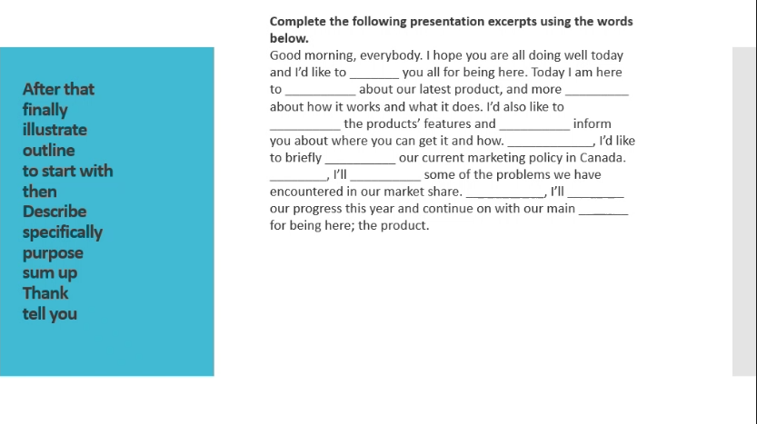

24/02/2023

What are the different social networking platforms that you know?

Which ones do you use on a daily basis?

For what purposes

What new features would you like to see on social media?

Argumentative essay writing

Social media does more harm than good. To what extent do you agree?

Yes social media are harmful and no it is not so harmful

Both sides

A hook

Une amorce

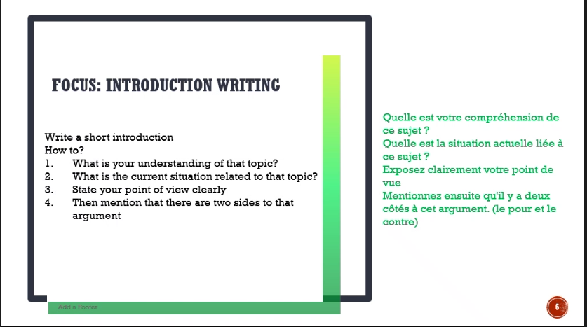

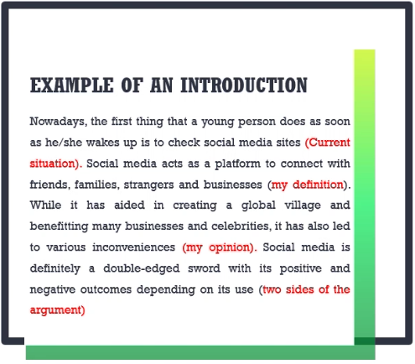

Argumentative essay writing

Social media does more harm than good. To what extent do you agree?

Nowadays, more than 4 billion people use social media. This represents more than half of the population. Social media enable users to communicate with family or friends and also to create and share content. While social media contributes to make life easier it has led to addictions. As long as there is a moderate use it can be really helpful, on contrary it can lead to dependence if uses spend too much time on it.

08/03/2023

Topic sentence will introduce the main idea of the paragraph because is paragraph need to have a main idea.

Body paragraph

T- Topic sentence

R- Reason for this opinion/claim

E- Elaborate

E- Example (to support the main idea)

C- Conclusion

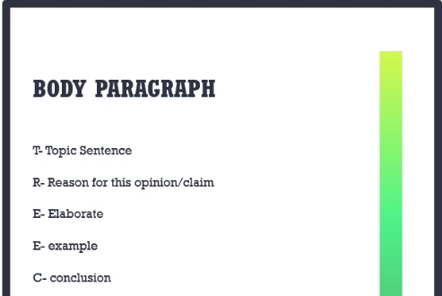

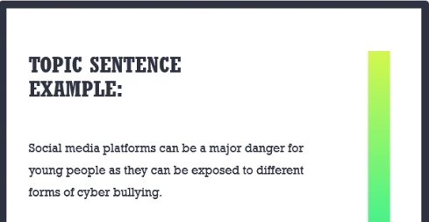

Argumentative essay writing

Social media does more harm than good. To what extent do you agree?

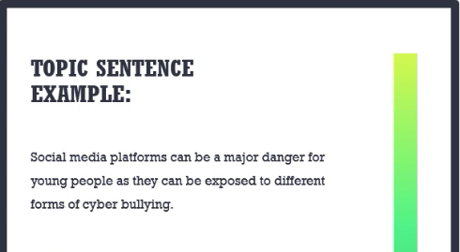

Some people use social media platforms lightly as they are not unaware of the risks. There are a lot of scammers on those platforms ready to steal your savings

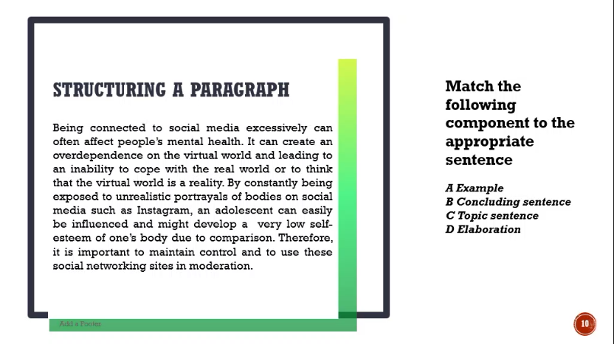

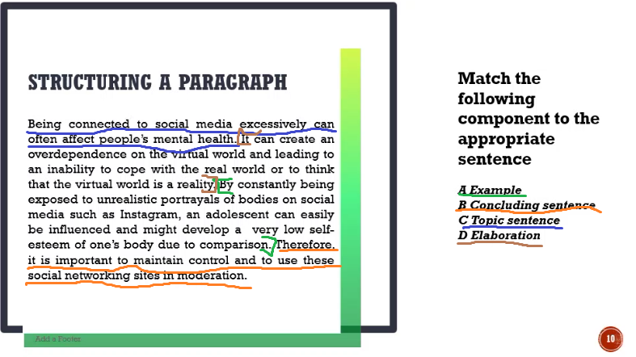

Some people use social media platforms lightly as they are not unaware of the risks. There are a lot of scammers on those platforms ready to steal your savings. It can lead to a precarious situation due to the inability to pay the daily expenses and even lead to depression. Those who are most at risk are the young and the elderly who do not have detailed knowledge of this kind of practice. It is therefore essential to warn them of the risks involved.

Table of contents

31/03/2023

What are the different reasons for writing a business letter?

Marketing letters, marketing emails,etc

Reasons for business letters

Inquire: faire une demande

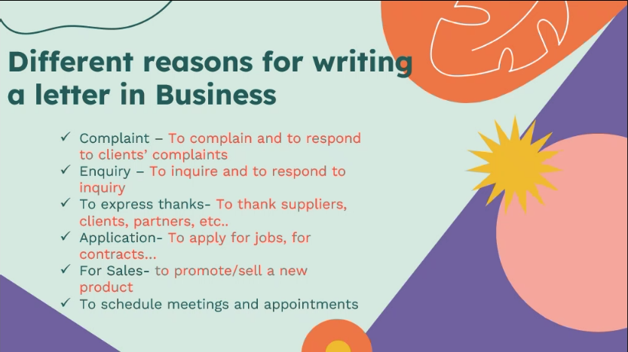

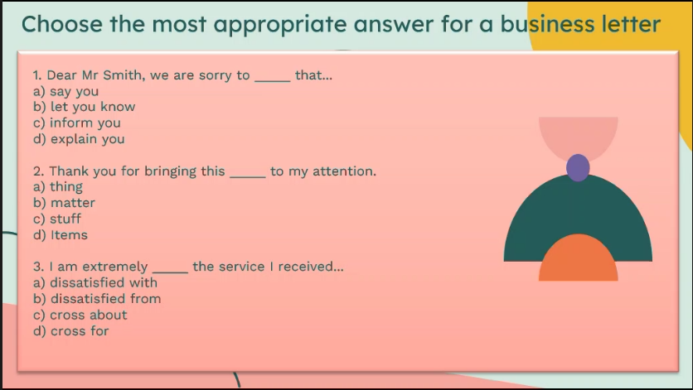

* + 1. Inform you (let you know = informal, say you= not English, inform to you)
    2. Matter
    3. Dissatisfied with

Cross about = être en colère

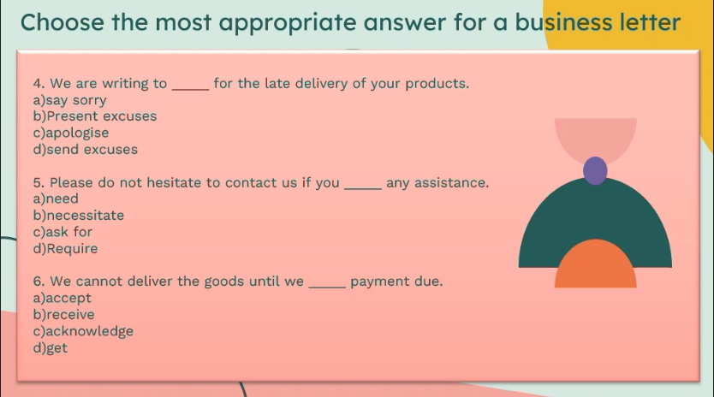

* + 1. Apologize (need=les s formal, necessitate= too much, ask for= informal)
    2. Require
    3. Receive

Acknowledge = prendre conscience

Different spelling –different meanings

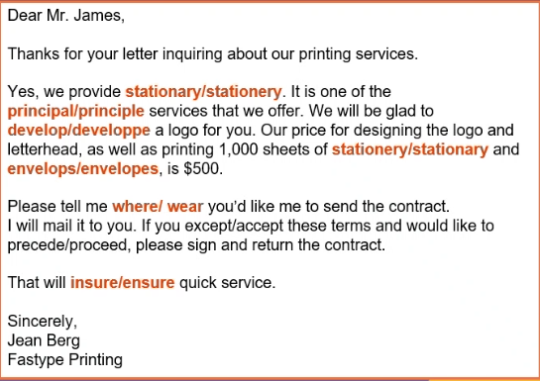

Stationery = papetterie; stationary= stationer

Principal = important, main; principle = principes

Develop; developpe = wrong, we don’t write it like that

Stationery

Envelopes

Where

Accept

Proceed; precede=précéder

Ensure; insure= assurance

Bloc formatting

Respond to complaint letter worksheet

1= senders name and address

2= letter date

3= recipients name

Format of a formal letter

1= Sender’s name

Sender’s address

(Leave a line) XXXXXXXXXXXXXXXXXXXXXXXXXXXXXXXXX

2= Date in full form (3st March 2023)

(Leave a line) XXXXXXXXXXXXXXXXXXXXXXXXXXXXXXXXX

3= Recipient’s name (receiver’s name)

Recipient’s Address

XXXXXXXXXXXXXXXXXXXXXXXXXXXXXXXXXXXXXXXXX

4= Subject (Ref: Topic of letter)

XXXXXXXXXXXXXXXXXXXXXXXXXXXXXXXXXXXXXXXXX

5= Dear Sir or Madam,

6= Reason for writing ( I am writing to ….)

7= Acknowledge, hearing the customer complaint

Understand his/her frustration

8= apologising for the situation

9= finding solutions

10= thanking the customer (thank you for taking this matter in consideration. I am looking forward to hearing from you)

11= Closing greetings (Yours faithfully, Kind regards, Best regards, yours sincerely)

Signature

Name and surname

Contact details

Complaint:

Hear the customer complaint

Empathy 🡪 understand his/her frustration

Apologise for the situation

Resolve the problem (find solution)

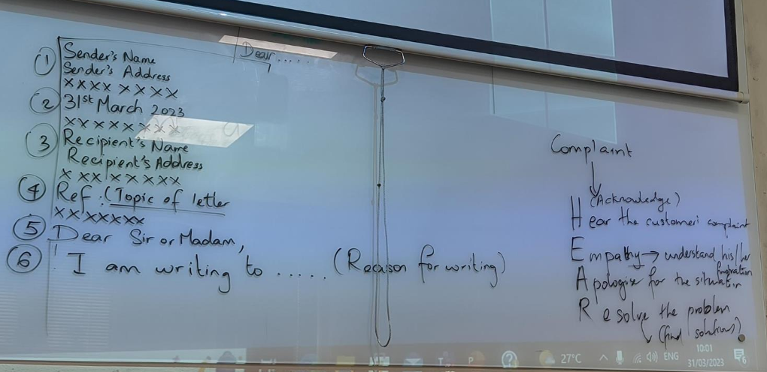

Letter of complaint

* 1. Name, address (sender)

XXXXXXXXXXXXXXXXXXXXXX

* 1. Date (in full) (07 April 2023) or (7th April 2023)

XXXXXXXXXXXXXXXXXXXXXX

* 1. Receiver’s name and address
  2. Subject/ref(reference)
  3. Dear…(Sir/Madam)
  4. Reason for writing
  5. Hear the customer (Body paragraph)

Empathy

* 1. Apologizing
  2. Resolution
  3. Thanking
  4. Closing /greetings (Kind regards, Yours faithfully)
  5. Signature
  6. Name and position

Letter

* 1. Name, address (sender)

XXXXXXXXXXXXXXXXXX

* 1. Date (in full) (07 April 2023) or (7th April 2023)

XXXXXXXXXXXXXXXXXX

* 1. Receiver’s name and address
  2. Subject/ref(reference)
  3. Dear…(Sir/Madam)
  4. Reason for writing
  5. Body paragraph (content)
  6. Thanking
  7. Closing /greetings (Kind regards, Yours faithfully)
  8. Signature
  9. Name and position

Essay writing

Intro:

1. Hook
2. Contextualisation
3. Thesis

Body (p):

1. Topic sentence
2. Reason
3. Elaborate
4. Example
5. Concluding sentence

Conclusion:

1. Sum up (in one sentence)
2. Call to action (what can be done?)

05/04/2023

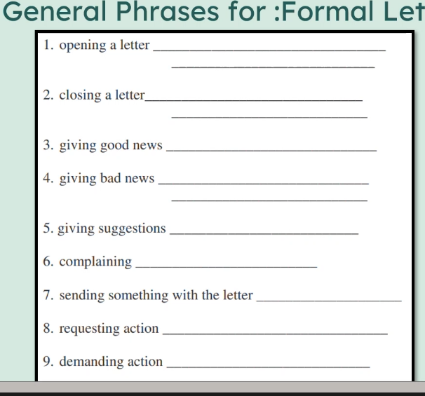

1. I am writing to inform you, I am writing to complain, I am writing to response/ With reference to your complaint, I would like to express my sincere apology/ I am writing to make a request/
2. Thank you for taking this matter into consideration. I look forward/I am looking forward to hearing from you /or to meeting you soon.
3. We are pleased to inform you that/ I would like to share some good news with you/ It is with much pleasure that I inform you that/ Inform you about
4. We regret to inform you that/ unfortunately I must inform you that/ It is with much regret that I have to inform you
5. I’m writing this letter to suggest/ One possible suggestion could be/ I would like to make the following recommendations/ I would like to recommend/
6. I am writing to complain/ I am disappointed with/ I would like to express my dissatisfaction with the service
7. Please find attached / Kindly find enclosed/ annexed
8. I would appreciate if the following actions are taken/ I would be grateful if you could
9. We urge you to take the following actions/ We urge you to follow this sets of procedures/ this steps/

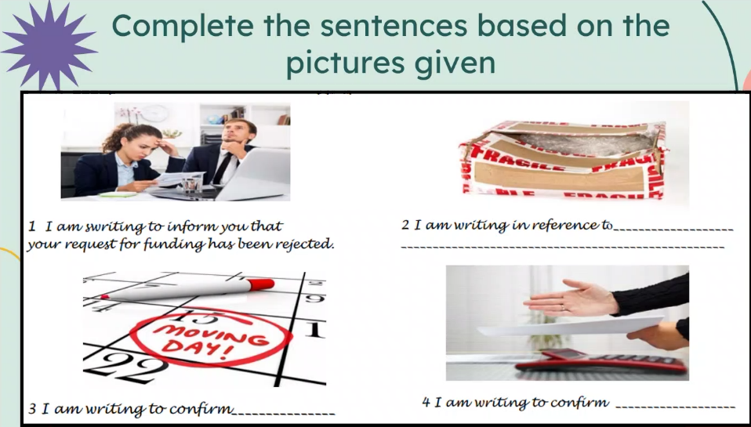

2. I am writing in reference to the damage (opened) parcel that I have received from your company

3. I am writing to confirm that the moving day has been scheduled for the fifteen of April 2023.

4. I am writing to confirm the deal that we have discussed (made, contracted) on … .

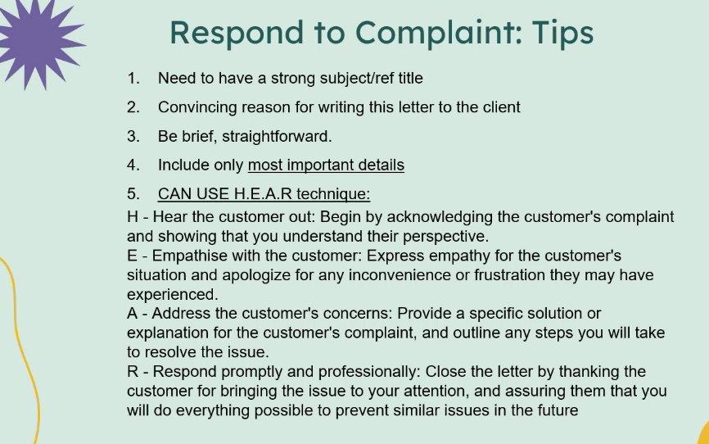

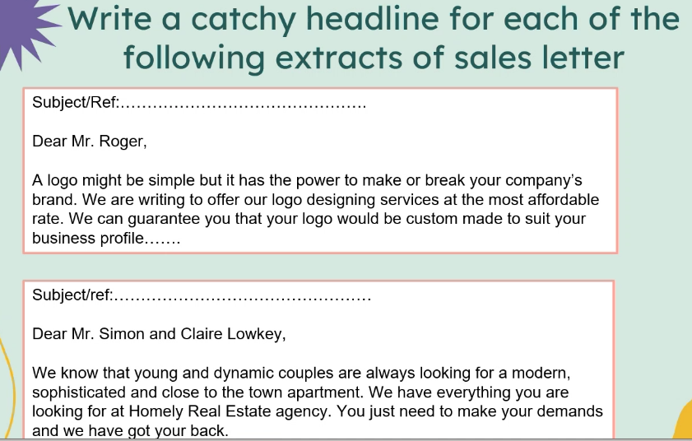

19 April writing test on a letter or either an essay !!!!!!!!!!!!!

07/04/2023

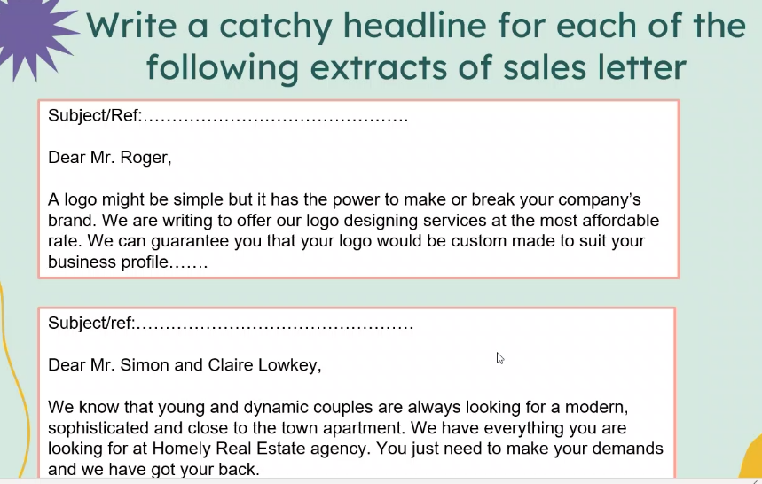

1. Subject: Logo designing services/ Most affordable logo services
2. Subject:/ref: Proposal of the best town apartments by our real estate agency

Email: [Request] Topic

Letter: Topic

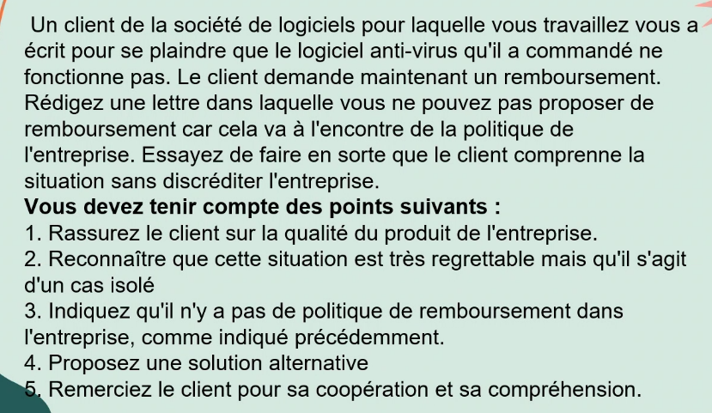

MANDANANAHARY Sarobidy

Ebene cybercity

07 April 2023

L’AIGUILLE Élisée

Chagos

Subject: Reimbursement about the anti-virus software

Dear Mr L’Aiguille, I am writing to inform you about the complaint that we have received from you about the issues that you have encounter with our anti-virus software.

It’s the first time that we encounter this situation. Our anti-virus software is the best in the market and we have never received any complaint about the anti-virus not working.

I understand your frustration about the issues that you have encounter and I apologise for the inconvenience caused by this problem but I regret to inform you that we don’t have reimbursement policies for this product.

But I can contact customer support on your behalf and had them contact you so they can try to resolve your issue.

Thank you for your understanding.

Faithfully yours,

MANDANANAHARY Sarobidy

After sales service agent.

12/04/2023

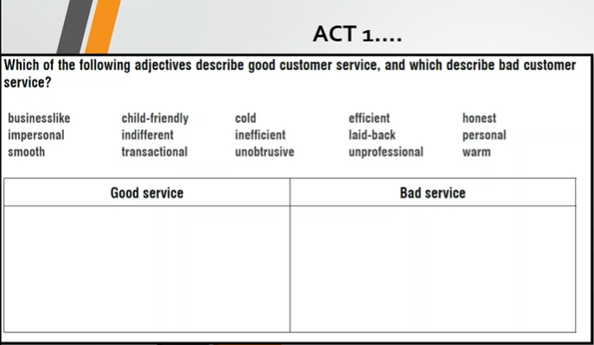

|  |  |
| --- | --- |
| Good service | Bad service |
| Businesslike (corporate, professional)  Smooth (going on naturally)  Child-friendly (adapted to children, kids)  Unobtrusive (discreet)  Efficient  Laid-back (décontracté)  Honest  Personal  warm | Impersonal (no focus on the customer)  Indifferent  Transactional  Cold  Inefficient  Laid-back (a bit too chill)  Unprofessional |

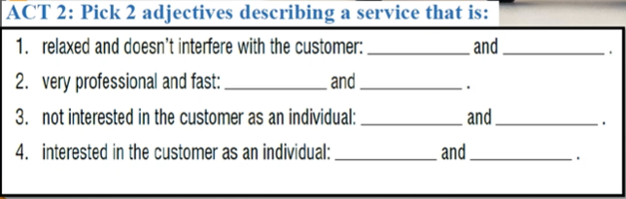

* + 1. Unobtrusive and laid-back
    2. Businesslike and efficient
    3. Impersonal and indifferent
    4. Personal and warm

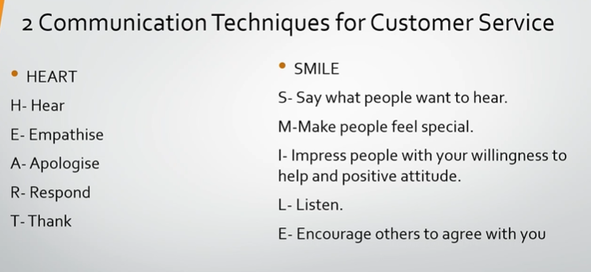

Reply =

Respond = you think well, you take the emotion of the person in consideration, you are polite, consider politeness, person, timing, tanking the customer

Heart = éric en français

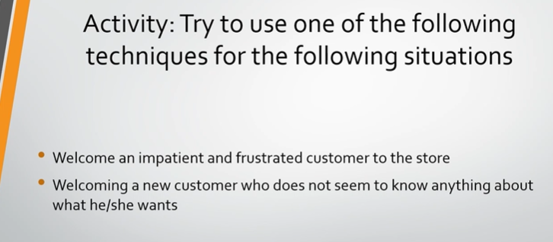

Communication Techniques for Customer Service

• HEART

H- Hear

E- Empathise

A- Apologise

R- Respond

T-Thank

• SMILE

S- Say what people want to hear.

M-Make people feel special.

l- Impress people with your willingness to help and positive attitude.

L- Listen.

E- Encourage others to agree with you

Activity: Try to use one of the following techniques for the following situations

• Welcome an impatient and frustrated customer to the store

• Welcoming a new customer who does not seem to know anything about what he/she wants

Employee= Élisée

Customer = Manoa

Employee: "Hello, welcome to our store! Is there anything you're interested in today?"

Customer: "Um, I'm not really sure. I'm just looking around."

Employee: "I'm here to help you find what you need. Have you shopped with us before, or is there a particular product you're looking for?"

Customer: "No, I haven't shopped here before. I just need some new clothes."

Employee: "Okay, great! We have a wide selection of clothing for men and women. Are you looking for something specific, like casual wear or formal wear?"

Customer: "I think I need some new work clothes. What do you recommend?"

Employee: "For work clothes, we have a great selection of dress shirts, blouses, and dress pants. Let me show you our most popular items. Are you looking for something more traditional or something more modern?"

Customer: "I prefer something more modern."

Employee: "Excellent! Our modern collection includes some great options for the workplace, like this slim-fit dress shirt and these ankle pants. We have a lot of happy customers who love these items. Would you like to try them on or see more options?"

Customer: "Hmm, those do look nice. But I'm not sure if they'll fit me properly. I'm quite thin, and I often have trouble finding clothes that fit well."

Employee: "Not to worry! We have a variety of sizes available, and our friendly staffs are here to help you find the perfect fit. Would you like me to help you find your size or show you some more options?"

Customer: "Yes, please. I'm not really sure what size I am."

Employee: "No problem at all. Let's measure you to determine your size. We have a sizing chart here that will help us find the perfect fit for you. Would you like me to assist you with that?"

Customer: "Yes, please. That would be great."

Employee: "Wonderful. Let's head over to our fitting rooms, and I'll show you how to use our sizing chart. Once we determine your size, we can find some more options that will look great on you."

14/04/2023

15m x 36m (fifteen by thirty six)

8:25 p.m (twenty five past eight)

16:45 quarter to 5

31st firsty first

30th thirty erth

23rd twenty third

Author, Source (website, magazine), publication date, title, know the main theme

Summary: introduction with the author, with the date, with the publication source, the main theme in the intro

Development, conclusion

21/04/2023

Embarass

Acknowledge

Occurred

Tomorrow

Summary

Occasion

operational

absence

Impede

Fathom

Ironic

Hierarchical

Interrupt

Explicit

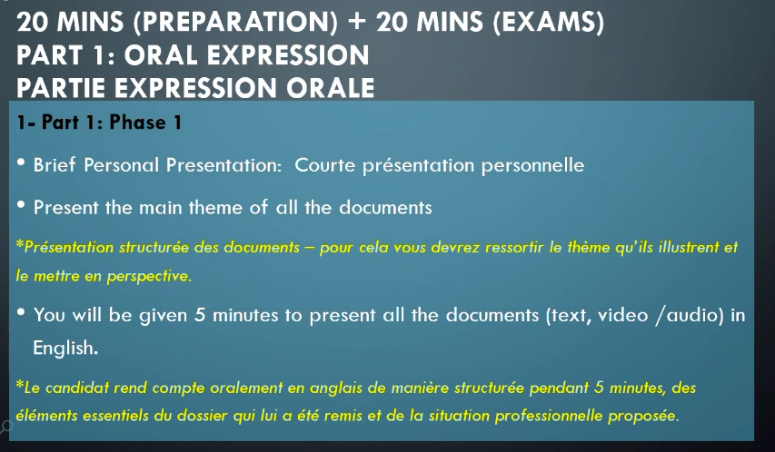

I’m currently doing a diploma in computer science

BYOD: bring your own device

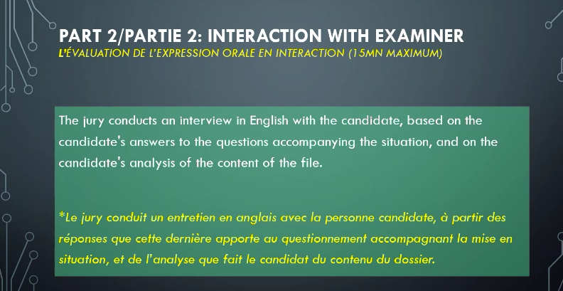

3 documents + mise en situation

5 minutes de présentation

5 minutes sur la situation

10 minutes sur la mise en situation

Oral presentation :

20 minutes for preparation (analise the documents)

3 documents + mise en situation (5 minutes)

5 minutes d’entretien

10 minutes mise en situation

This paper consist of (comprises of) 3 documents, and all of them are related to (main theme)

26/04/2023

Scattergories

|  |  |  |  |  |
| --- | --- | --- | --- | --- |
| Positive adjective to describe a manager | An activity that you do at work | Name of a company | Region | Job title |
| Bold | Budgeting | Barclays | Boston | Business analyst |
| Talented/ trustwothy | Typing/training | Tata motors/ tesla | Tamarin/ texas/ Tokyo | Tailor/ teacher |
| Motivating | Marketing | Microsoft | Miami | Manager/musician |
| Wonderful/wise | Write/writing | Walmart/warner bros/walt Disney/wikipedia | Wallony/Washington | Writer/waiter/web developer |

BYOD policy

Present the documents

Firstly document A is an article, it has been written by Brown in 2023 and it was published on the website ….com The main theme is the policies that has to be followed by the BYOD devices. I will now mention the main ideas that I have identified from the text

Intro:

Document A is an article that has been written by Scuiler Brown in 2023and published on the website strongdm.com. This article discusses the main factors to be considered when writing and building the BYOD policy. I will now present the main ideas of this article.

BYOD policy should comprise of

1. Confidential data that are not to be stored on the device
2. Processes to report lost or stolen devices/data

BYOD can be quite challenging specially when trying to control the employee’s devices. That is why the author mentions that some applications which can interact with company data should be restricted and strong passwords and PIN should be defined.

MDM (mobile device management) solutions can provide additional control for better management of BYOD. On top of that Sculer Brown states that careful analysis of MDM is necessary before selecting one as some vendors could possibly have better regulations for specific devices taps.

Confidential data store on the devices

Devices need to be protected

Ne pas oublier de souligner le “Subject » ou « ref » dans une letre !!!

05/05/2023

Cloud computing

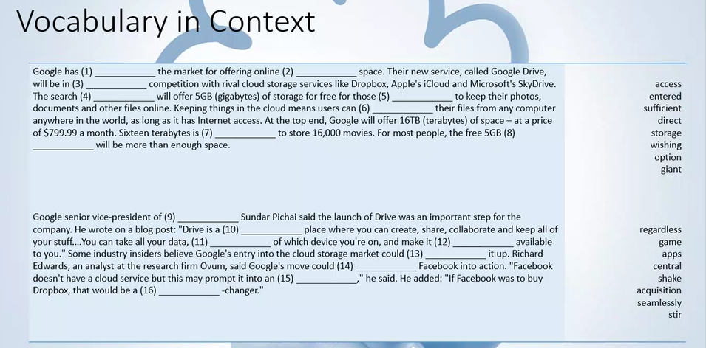

Seamlessly = without problem, without much effort

Central place = the most important

Shake it up = apporter du nouveau

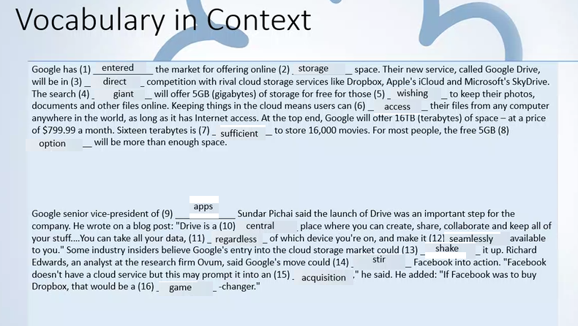

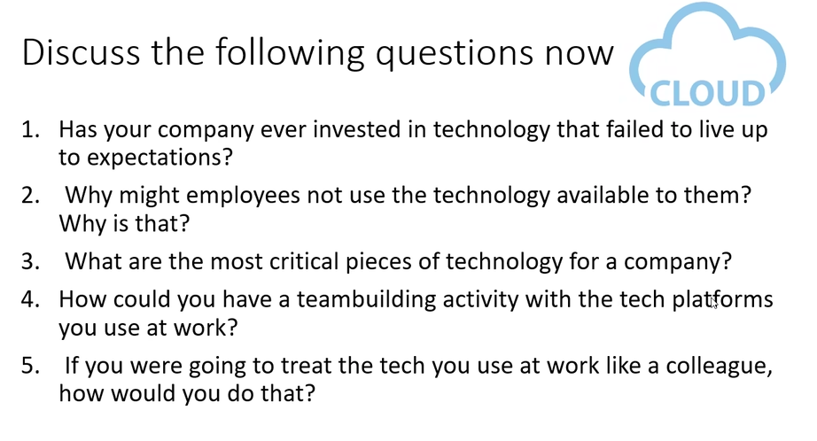

17/05/2023

Letter/essay/email

Compte rendu en français

BTS blanc écrit

1ere partie : comprehension (article, extrait livre etc)

2ème partie: expression écrite (letter/essay/email)

Correct the mistakes in the following sentences :

1. “I’m sorry, I didn’t catch what you said,” said the man during the meeting.
2. We should have launched our new product last month.
3. We are going to lose a lot of money if we don’t take actions soon.
4. We were hoping to launch the product next month.
5. “Please let me know if you are (you’re) able to attend the meeting.”
6. “I have much experience in this field.”
7. “Our company is expanding rapidly”.
8. “The data’s show that the majority of customers were satisfied.”

Complete the following sentences with the correct verb tenses.

“We (to launch) the new product next month.”

“The team (to work) on the project for 6 months now.”

“Yesterday, we (to meet) with the client to discuss the contract.”

“I (to finish) the presentation by 5 PM.”

“The company (to increase) its sales by 20% this year.”

“Last week, the team (to present) the project to the management.”

“We (to have) a meeting with the stakeholders next week.”

“The company (to launch) a new marketing campaign next month.”

“I (to work) for this company for 5 years now.”

“We (to discuss) the budget at the meeting tomorrow.”

“We will launch the new product next month.”

“The team has been working on the project for 6 months now.”

"Yesterday, we met with the client to discuss the contract."

"I will finish the presentation by 5 PM."

"The company has increased its sales by 20% this year."

"Last week, the team (had) presented the project to the management."

"We will have a meeting with the stakeholders next week."

"The company is launching (will launch) a new marketing campaign next month."

"I have been working for this company for 5 years now."

"We will discuss the budget at the meeting tomorrow."

Fill in the blank with the correct preposition

1. We need to focus on our core competencies.
2. The training session will be conducted for (with) the new employees.
3. The product is designed for customers who value quality.
4. The presentation was well-received by the audience.
5. We need to adhere to the company’s policies and procedures.
6. The company is committed to providing excellent customer service.
7. The company is investing heavily in research and development.
8. We need to be proactive in identifying new business opportunities.
9. The sales team is working closely with the marketing department.”
10. The project is progressing in schedule.
11. We need to be mindful about the impact of our decisions.
12. The company is known for its innovative products and services.
13. The company is expanding its operations in Asia.
14. We need to be flexible with changing market conditions.
15. The team is responsible for the project’s budget.

24/05/2023

Email writing:

To: email address

CC:

BCC:

Subject: [ Action (e.g. request, information, demand, feedback) ] Key topic

Dear Sir/Madam or Dear Mr ……, Dear Mrs …

XXXXXXXX

Body Paragrapph

XXXXXXXXXXX

Kind regards,

Name and surname,

Position/Job title.

Essay writing:

Intro: (25-30 words)

* Hook
* Contextualisation (what is happening currently, what is being done in relation to the topic)

Body paragraph:

* Topic sentence (introduce the main idea of the paragraph
* Reason why we are using this idea
* Elaborate
* Example

Body paragraph:

….

(3-4 main ideas, don’t copy examples from the article)

Conclusion

Paragraph (4-5)

Compréhension:

* Titre
* Theme principale
* Source
* Date de publication
* Auteur
* Nature du document

Compte rendu : conclusion du texte, reformulé

Essay review exercise

Building and maintaining strong relationships with key stakeholders is **essential (key, crucial for the success) for the success and sustainability** of any business. Business leaders can use a variety of strategies to **nurture (improve, foster)** these relationships and ensure that all parties are aligned and **working towards** shared goals.

First and foremost, communication is key. Business leaders should **actively engage (interact, establish an open communications)** with all stakeholders, regularly providing updates on the company's **progress, initiatives, (challenges)** and **plans** for the future. They should also actively seek out **feedback** and input from stakeholders, demonstrating that their opinions are valued and taken into consideration.

Another important strategy is to establish **a culture** of transparency and trust. Business leaders should be **open and honest** about any issues or challenges the company is facing, and take **proactive steps to address** these concerns in a timely and effective manner. This can help to build trust with stakeholders and demonstrate the company's commitment to **ethical and responsible** practices.

Business leaders can also foster strong relationships with stakeholders by actively **participating outside** of formal business settings. This can include participating in community events, **volunteering**, or supporting **charitable** causes. By demonstrating a commitment to social responsibility, business leaders can build strong relationships with community members and showcase the company's values.

All in all, it is important for business leaders to recognize and appreciate **the contributions of their stakeholders.** This can include acknowledging and rewarding employee achievements, providing **opportunities for professional development,** or providing investors with regular updates on the company's performance. By showing appreciation and recognizing the efforts of stakeholders, business leaders can **strengthen relationships and foster a sense of loyalty and commitment**.

26/05/2023

Titre: Lorsque la technologie devient une perte de temps : Comment retrouver sa productivité au travail

Thème principal: L'impact des avancées technologiques sur la productivité au travail et les mesures pour y remédier.

Source: Forbes Magazine

Date de publication: Février 2022

Auteur: Jose Luis Gonzalez Rodriguez

Nature du document: Article d'opinion

Dans cet article publié dans Forbes Magazine en février 2022, l'auteur Jose Luis Gonzalez Rodriguez aborde le sujet de l'impact des technologies sur la productivité au travail. Il souligne que malgré les nombreux avantages apportés par la révolution technologique, ces avancées ont également engendré des pratiques inefficaces qui compromettent la productivité des entreprises. Selon l'auteur, plus de 90% des personnes perdent entre 15% et 40% de leur journée de travail en raison de l'utilisation inappropriée des technologies numériques.

Trois principales sources de perte de temps sont identifiées dans l'article. Premièrement, les e-mails, qui peuvent être des outils utiles mais qui peuvent également générer des interruptions et des distractions. Deuxièmement, les applications de messagerie, telles que What'sApp, qui entraînent des interruptions constantes et empêchent la déconnexion du travail. Troisièmement, les réunions et téléconférences excessives qui résultent souvent d'un manque de définition des responsabilités et des fonctions de chaque poste.

L'auteur propose plusieurs mesures pour retrouver sa productivité au travail. Il suggère de créer des créneaux horaires spécifiques pour la gestion des e-mails, d'éliminer les notifications et les signaux sonores des appareils, de se désengager des groupes de messagerie inutiles et de définir clairement les rôles et les responsabilités de chaque employé.

En mettant en place ces mesures correctives, les entreprises pourront constater une amélioration significative de leur productivité, tandis que les employés bénéficieront d'une réduction du stress et d'une motivation accrue.

Mots utilisés: 200

- La révolution technologique a apporté des améliorations significatives à la productivité et à l'efficacité des entreprises.

- Cependant, plus de 90% des personnes perdent entre 15% et 40% de leur temps de travail en raison de l'utilisation inefficace des technologies.

- Les principales sources de perte de temps sont les e-mails, les applications de messagerie et les réunions excessives.

- Les interruptions constantes causées par les notifications d'e-mails et les messages perturbent la concentration et génèrent du stress.

- Les informations partagées dans les groupes de messagerie ne sont souvent pas pertinentes pour la majorité des membres, entraînant des distractions supplémentaires.

- Les réunions et les téléconférences excessives résultent d'un manque de définition des responsabilités et des fonctions de chaque poste.

- Pour retrouver la productivité, il est recommandé de créer des plages horaires dédiées à la gestion des e-mails, de désactiver les notifications et les signaux sonores, de quitter les groupes de messagerie inutiles et de clarifier les rôles et les responsabilités de chaque employé.

- La mise en place de mesures correctives permettra aux entreprises de réaliser des progrès significatifs en termes de productivité, tandis que les employés bénéficieront d'une réduction du stress et d'une motivation accrue.

Dans cet article paru dans Forbes Magazine en février 2022, l'auteur, Jose Luis Gonzalez Rodriguez, parle de l'impact des technologies sur la façon dont nous travaillons. Il explique que bien que les nouvelles technologies aient de nombreux avantages, elles ont aussi créé des habitudes qui sont inefficaces et qui nuisent à notre productivité. Selon l'auteur, plus de 90% des personnes perdent entre 15% et 40% de leur temps de travail parce qu'elles utilisent mal les outils technologiques.